Agradecimentos
Nenhuma aprendizagem e, muito menos pesquisa científica, são feitas em isolamento. É um constante trabalho em equipa que resulta num sincero reconhecimento a vários níveis.

Em primeiro lugar, dirijo a minha sincera gratidão ao Professor Miguel Castelo-Branco pela sua orientação científica e inestimável transmissão de conhecimentos ao longo da realização deste trabalho, bem como por me proporcionar os meios necessários para o desenvolver.

Agradeço também à Inês Violante por todo o apoio disponibilizado, principalmente em relação à espectroscopia, bem como à sempre valiosa troca de ideias e conselhos ao longo deste trabalho.

Agradeço à Dra. Guiomar Oliveira, Presidente da Unidade de Neurodesenvolvimento e Autismo do Centro de Desenvolvimento Luis Borges, e especialmente à Susana Mouga por ter desempenhado um papel fundamental neste projecto, estabelecendo a ponte entre o IBILI e as famílias dos participantes. À sua contribuição, bem como à da Inês Bernardino, na avaliação dos participantes, o meu obrigada.

Quero ainda agradecer a toda a equipa do grupo MCB, onde logo me senti à vontade, pela colaboração, amizade e divertimento proporcionados!

A todos os que de uma forma ou de outra contribuíram para o meu percurso ao longo deste desafio, o meu mais sincero agradecimento.

Quero, por fim e principalmente, expressar toda a minha gratidão e admiração aos meus pais, Eugénia e João Pereira, meus modelos para a Vida! A eles e ao meu irmão, João André, dedico este trabalho!
Um sincero obrigada,
-------------------------------------------------
Andreia Sofia Carvalho Pereira

Abstract
Autism Spectrum Disorder (ASD) is a group of lifelong neurodevelopmental syndromes characterized by impairments in social interaction, communication and by repetitive behaviors and narrow range of interests.
Magnetic resonance imaging (MRI) and proton magnetic resonance spectroscopy (¹H-MRS) studies have detected widespread brain alterations in ASD but a consistent neuropathophysiological characterization is still missing.
The great phenotypic and genetic variability present in this spectrum of clinical manifestations suggests the existence of disease-related clusters that warrant careful investigation.
We used MRI to measure cortical thickness and subcortical volumes and ¹H-MRS to study the neurochemical profile of the anterior cingulate cortex in a homogenous sample of adolescents and adults diagnosed with ASD. With this protocol we intended to identify both anatomical and neurochemical differences that could distinguish between ASD and the control group.
We found evidence, in the ASD group, of increased cortical thickness and volume, of cortical and subcortical structures related to the core ASD deficits: automatic and goal-oriented behaviour. Affected cortical regions were manly located in the left hemisphere and have been implicated in social and emotional cognition. Morphometric correlations were also present between striatal structures and regions implicated in language and motor control.

Key-words: Autism, morphometry, basal ganglia, frontal lobe, spectroscopy

Resumo
As Perturbações do Espectro do Autismo (PEA) são doenças do neurodesenvolvimento caracterizadas por défices na interacção social, comunicação e por comportamento repetitivos e estereotipados acompanhados por um leque reduzido de interesses e actividades.
Estudos com imagem por ressonância magnética (IRM) e espectroscopia de protão por ressonância magnética (EPRM) têm evidenciado alterações cerebrais difusas em pessoas com PEA, no entanto uma caracterização neuropatofisiológica clara ainda não foi encontrada.
A grande variabilidade fenotípica e genética encontrada neste espectro de manifestações clínicas, sugere a existência de subpopulações clínicas que é necessário estudar atentamente.
Numa população homogénea de adolescentes e adultos com PEA, usámos IRM para medir a espessura cortical e o volume de estruturas subcorticais e usámos EPRM para estudar o perfil neuroquímico do cíngulo frontal. Com esta abordagem quisemos identificar alterações anatómicas e neuroquímicas que nos permitissem distinguir entre o grupo das PEA e o grupo controlo.
Foi observado, grupo das PEA, um aumento de espessura cortical e do volume de regiões corticais e subcorticais que têm sido relacionadas com défices no comportamento automático e executivo. As regiões corticais afectadas encontraram-se principalmente do hemisfério esquerdo, estando relacionadas com a cognição social e emocional. Também foram observadas correlações morfométricas entre estruturas pertencentes ao estriado e zonas corticais relacionadas com a linguagem e o controlo motor.

Palavras-chave: Autismo, espessura cortical, estruturas subcorticais, neuroquímica

Table of Contents
List of Figures 1
List of Tables 2
1 Introduction 3
2 State of the Art 5
2.1 Autism Spectrum Disorders - Clinical overview and Prevalence 5
2.2 Neuroanatomy of Autism Spectrum Disorders –in vivo morphometry 6
2.2.1 Cortical Thickness 7
2.2.2 Subcortical structures 9
2.2.3 The Limbic System – Hippocampus, Amygdala and Anterior Cingulate Cortex 10
2.3 Neurochemistry in Autism Spectrum Disorders 11
3 Neuroimaging techniques 14
3.1 Nuclear magnetic resonance (NMR) phenomenon 14
3.2 Magnetic Resonance Imaging – T1-weighted images 16
3.3 Proton Magnetic Resonance Spectroscopy 18
4 Motivation 20
5 Methods 21
5.1 Participants 21
5.2 Acquisition protocol 22
5.2.1 MRI acquisition 23
5.2.2 MRS acquisition 23
5.3 Data processing 24
5.3.1 Cortical thickness measurement and subcortical structures segmentation 24
5.3.2 MRS (LCModel) 27
5.4 Statistical Analysis 29
6 Results 30
No differences were found between the groups in age (p=0.435) or in intracranial volume (p=0.167), thus no corrections were needed for these two variables that could explain group differences in the subsequent analysis. 30
6.1 Brain morphometry 30
6.2 Magnetic resonance spectroscopy 32
7 Discussion 33
7.1 Spectroscopy of the anterior cingulate cortex 33
7.2 Morphometry 34
7.2.1 Cortical thickness 34
7.2.2 Subcortical structures 35
8 Conclusion 36
9 Appendix 1. 37
A. Cortical thickness analysis statistics 37

List of Figures

Figure 1 Brain regions that are involved in the putative neuronal systems implicated in the three core behaviors that show impairment in ASD. (Adapted from Amaral et al., 2008) 6
Figure 2. Spins orientation in: a) natural state, randomly distributed spins; b) following the application of a strong magnetic field B₀ the spins achieve one of two possible energy levels. (Adapted from Clinical MRI and Physics) 14
Figure 3. When a RF pulse (B₁) is applied to the constant B₀, a transverse magnetization appears (x,y). The transverse components vary with time as proton precesses. (Adapted from MRI – Basic principles) 15
Figure 4. T1-weighted image of the brain (axial view). White matter (WM) is the brightest signal; gray matter (GM) has a gray color; cerebrospinal fluid (CSF) in the ventricles is dark. This type of image provides very good contrast between white matter and gray matter allowing morphometric analysis of these tissues. 17
Figure 5. Typical 1H spectrum from normal brain. (Adapted from MRI –Basic Principles and Applications). 19
Figure 6. An SMI Eyetracker device was used monitor the subjects during the exam. 22
Figure 7. Localization of the MRS voxel in the anterior cingulate cortex (ACC) in a T1-weighted image. a) sagittal view; b) coronal view and c) axial view. 23
Figure 8. The average of two anatomical acquisitions improves the signal-to-noise ratio (SNR), resulting in a better quality image, appropriate for subsequent segmentation. a) one single anatomical acquisition; b) average of two anatomical acquisitions with improved SNR. 24
Figure 9. Subcortical segmentation. 1) Putamen; 2) Pallidum; 3) Amygdala; 4) Hippocampus; 5) Caudate; 6) Thalamus. The Accumbens is not visible in this slice. 25
Figure 10. Pial (red) and white matter (yellow) surfaces. 26
Figure 11. Desikan-Kiliany atlas projected in the inflated surface of a right hemisphere (lateral view). 27
Figure 12. LCModel fitting (red line) of a spectrum obtained from one PRESS acquisition NAA, N-acetylaspartate; Glx, glutamate + glutamine; Cr, creatine + phosphocreatine; Cho, choline-containing compounds; Ins, inositol-containg compounds. 28
Figure 13. a) Medial surface; b) Lateral surface (http://web.mit.edu/mwaskom/pyroi/freesurfer_ref.html#destrieux-atlas-2009). 30
Figure 14. Bars represent mean(SE) for the Glu, Ins, GPC+PCh. NAA+NAAG and Cr+PCr. No statistical differences were detected between groups. 32

List of Tables
Table 1. Brain metabolites concentration comparisons between the two groups. 32

Introduction

Neuroimaging techniques, such as magnetic resonance imaging (MRI) and magnetic resonance spectroscopy (MRS), have revealed structural and neurochemical alterations throughout the brain in Autism Spectrum Disorders (ASD). However, a great variability of results exists among studies with non-replicated or even contradictory findings reported using both techniques. Consequently, a unifying neuropathophysiological account of the developing brain of people diagnosed with autism is still lacking. The heterogeneity of neuropathological findings is in part due to methodological issues, but is also a consequence of the great phenotypic variability present in the ASD suggesting the existence of clinical subgroups sharing common characteristics. Thus, there is the need to study homogeneous groups (behaviourally, biochemically and genetically) in order to unravel brain-behaviour relationships in clearly established disease-related clusters.
This type of research has been conducted in several countries like the United Kingdom, United States of America, Brazil, Japan, China, but was never done in the Portuguese population. Moreover, the combination of techniques has rarely been attempted. Here we present a magnetic resonance imaging (MRI) and magnetic resonance spectroscopy (MRS) study in a sample of Portuguese adolescents and adults diagnosed with ASD.
In chapter 1, a clinical overview of the ASD is done, as well a brief review on the neuroanatomical and neurochemical findings. Regarding the neuroanatomy the focus will be on brain cortical thickness findings, volumetric findings on the basal ganglia and limbic system structures, namely the amygdala, hippocampus and anterior cingulate cortex.
In chapter 2, a brief description of basic principles of magnetic resonance imaging (MRI) and magnetic resonance spectroscopy (MRS) techniques are described in order to provide a general idea of how these techniques explore the magnetic properties of hydrogen protons to yield biologically relevant information for the in vivo study of the brain anatomy and biochemistry.
In chapter 3, the motivation of this work is outlined.
In chapter 4, the methodological approach for data acquisition is described, as well as an explanation of how the post processing softwares process the different type of data.
In chapter 5, the results of the anatomical study and the neurochemical study are reported.
Finally, in chapter 6, the main findings of this work will be discussed in light of the objectives and the current knowledge on the theme and in chapter 7, the conclusion of this work is presented as well as the perspectives for future work.

State of the Art

Autism Spectrum Disorders - Clinical overview and Prevalence
Autism Spectrum Disorders (ASD) - Autistic Disorder (AD), Asperger’s Syndrome (AS) and Pervasive Developmental Disorder – Not Otherwise Specified (PDD-NOS), is a lifelong heterogeneous group of neurodevelopmental syndromes. Symptoms appear early in childhood, usually before the age of 3, and are characterized by impairments in social interaction and by repetitive and stereotyped behaviors, usually, but not always, accompanied by verbal and non-verbal language deficits (DSM-IV, 2002). Besides the impairments in these three main core symptom clusters required for diagnosis, there are other areas of clinical dysfunction observed in a significant proportion of individuals diagnosed with autism. Intellectual disability is very common among ASD, and may be present in up to 70% of individuals (Fombonne, 2003). Epilepsy is present in 6-60% of the cases (depending on the sampling cohort), sensory abnormalities are observed in >90% of the individuals and are thought by some to be a core feature of ASD (reviewed in Geschwind, 2009). Moreover, at least one comorbid psychiatric disorder may be present in a very significant proportion of people with ASD (25-70% of cases) (Matson and Nebel-Schwalm, 2006).
ASD prevalence estimations vary among studies due to the different inclusion criteria used to define the samples. However, it is estimated that prevalence rates are 36.4 per 10 000 children (Fombonne, 2007). Also, boys are more affected than girls, with a ratio of 4.3 boys to 1 girl (Fombonne, 2007). In Portugal, prevalence estimates are close to 10 per 10 000 children with 15% of the patients in this cohort presenting associated medical disorders and 15.8% presenting epilepsy (Oliveira et al., 2007). ASD are a group of severe lifelong neurodevelopmental disorders with a significant economic and social impact due to its high prevalence, morbidity, outcome and impact on families.

Neuroanatomy of Autism Spectrum Disorders –in vivo morphometry
Given the heterogeneity of clinical features described in ASD it is not surprising that multiple brain regions have been implicated among studies (Error: Reference source not found). Furthermore, highly co-morbid disorders that show altered cortical morphology like intellectual disability (Kabani et al., 2001) and epilepsy (Jones et al., 2000) may be biasing the anatomical findings and are a matter of concern for the interpretation of the neuroanatomy in ASD.
Anatomical studies have highlighted regions in the frontal, parietal, and temporal lobes; amygdala, hippocampus and basal ganglia, with both gray and white matter abnormalities reported.

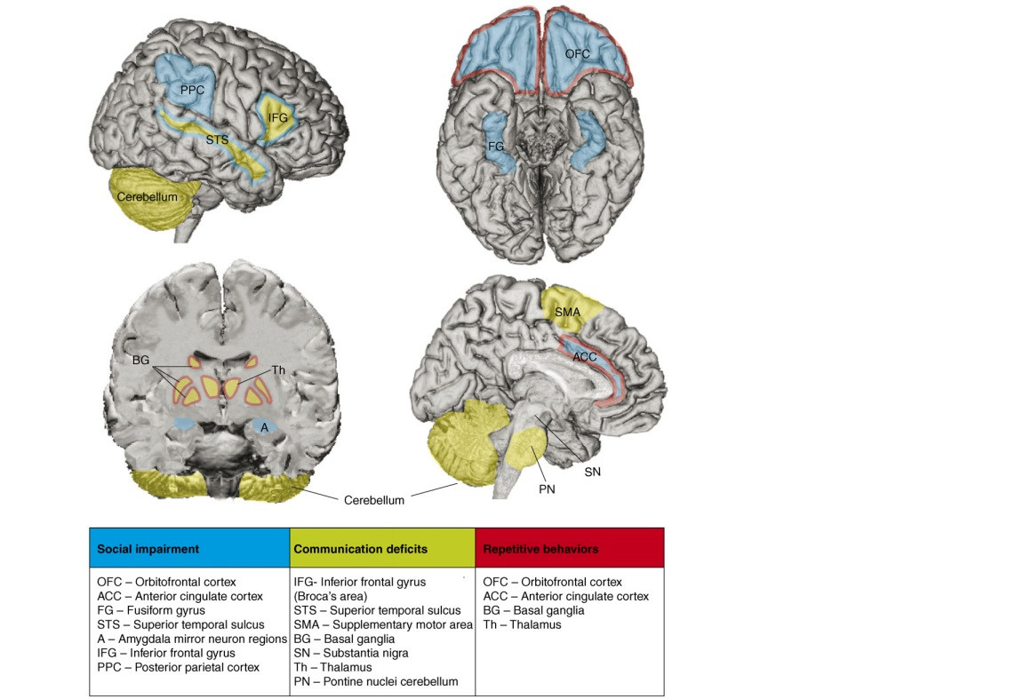
Figure 1 Brain regions that are involved in the putative neuronal systems implicated in the three core behaviors that show impairment in ASD. (Adapted from Amaral et al., 2008)

Moreover, brain overgrowth confined to early childhood, which is not present at birth or adult life has been a very prominent finding in ASD (reviewed in Courchesne et al., 2007), pointing to developmental alterations in a critical period of synapses/circuitry formation (Huttenlocher and Dabholkar, 1997).

Cortical Thickness
The cerebral cortex is a highly convoluted structure and the cortical thickness (CT) throughout one’s brain can vary greatly depending on the brain regions and on individual variability, but typical ranging between 1-4.5mm (Fischl and Dale, 2000). The cortical thickness varies depending on the region of the cortex, as well as between hemispheres of the same brain (Kabani et al., 2001).
The study of the CT is of great interest in both normal and pathological brain development with studies revealing CT variations associated with meaningful functional differences across groups (Jones et al., 2000, Shaw et al., 2006a).
Several MRI studies have reported gray matter abnormalities in ASD, namely in cortical thickness (CT) which may reflect dendritic arborization/pruning within gray matter (Huttenlocher and Dabholkar, 1997) and is therefore may be interpreted as an index of normal brain development (Schaer and Eliez, 2009).
While some studies reported regional decreases in CT (Chung et al., 2005; Hadjikhani et al., 2006; Wallace et al. 2010); others report increased (Hardan et al., 2006) or even a mixture of increased and decreased CT across regions (Hyde et al. 2010).
The regions of altered CT are not the same among studies, even though all the reported regions are putatively related to the core impairments seen in ASD (social interaction, communication, and repetitive behaviors).
One study found decreased CT in the inferior prefrontal cortex and superior temporal sulcus (Chung et al., 2005); other found decreases in temporal, parietal and frontal cortex (Hadjikhani et al., 2006); while another found decreased CT only in temporal and parietal cortices (Wallace et al., 2010). These were studies that analyzed only adolescents and adults with ASD.
Conversely, in a recent report Hyde and colleagues (2010) found mostly increases in CT in an adolescents and adults sample along several regions. These increases were related to the three core domains of impairment in ASD (social, communication, and repetitive behaviors). They also reported CT increases in the visual cortex and, for the first time, in the primary auditory cortex. Additionally, in this study the authors also reported a smaller group of areas with decreased CT in portions of the pre-, para- and post-central gyri, although they were a minority (Hyde et al., 2010).
One study in children (ages 8-12 years) reported CT increases in temporal and parietal lobes (Hardan et al. 2006).
Future work should identify methodological and sampling issues that might in part explain such discrepancies.
Age-related developmental changes in CT have been reported to be related to cognitive ability in typically developing children and adolescents, with the trajectory of the development (characteristically an inverted U shape) being more informative than simple crossectional measures (Shaw et al., 2006b). In ASD, longitudinal studies have been conducted in order to understand the developmental trajectories of CT (Hardan et al. 2009; Raznahan et al., 2010). Hardan and colleagues rescanned (after 30 months) the sample of the work performed in 2006 (Hardan, et al., 2006) and found that in the ASD group there was a greater thinning of the cortex in the previous reported regions (temporal and parietal) but also in the frontal and the occipital lobes. Although these differences were no longer significant after controlling for multiple comparisons (except for the changes in the occipital CT), a relationship between changes in the frontal lobe and lack of socioemotional reciprocity as well as the changes in the temporal lobe and repetitive behavior were detected (Hardan et al., 2009). It is noteworthy that these studies have included <20 participants, which limits the statistical power.
However, a recent study included 76 individuals with ASD and a wide range of ages (10
-60 years). Here, CT was negatively correlated with age in controls but not in ASD. Moreover, temporal CT was smaller in ASD children than controls, with this pattern being reversed by middle age/late adulthood when CT was greater in ASD compared to control, thus, suggesting that abnormal cortical maturation in ASD extends to adulthood (Raznahan et al., 2010).

Subcortical structures

Basal ganglia
The basal ganglia are a group of nuclei (striatum, substancia nigra and subthalamic nucleus) which in connection to other brain regions such as the prefrontal cortex are involved in inhibitory control and cognitive flexibility (Bradshaw and Sheppard, 2000). The main structure of the basal ganglia that has been implicated in ASD is the caudate nucleus.
An enlargement of the caudate nucleus has been reported in ASD (Sears et al., 1999; Hollander et al., 2005; Haznedar et al., 2006) and alterations in this region have been linked to the stereotyped and repetitive behaviors, due to a role in inhibitory behavior (Bradshaw and Sheppard, 2000) although the interpretation of behavioral correlates was conflicting. Sears and colleagues found increased caudate volumes in two independent ASD samples of adolescents and adults (Sears et al., 1999). Although in one of the samples the caudate increase was proportional to overall brain volume, there was an association with the severity of the repetitive and stereotyped behaviors. The lower order stereotypies (motor) were positively correlated with the caudate volume increase while the higher order (routines and severity of compulsions) were negatively correlated with this enlargement, with the authors hypothesizing that ritualistic behaviors in ASD could be associated with abnormal functional relationships between the caudate and other brain areas (e.g. frontal or temporal) (Sears et al., 1999).
In another study in an ASD sample of adolescents and adults (age range 17-55 years) an increase in the right caudate, even after controlling for total brain volume, was reported (Hollander et al., 2005). Additionally, an inversion of the asymmetry pattern of the caudate nucleus was found between the two groups. However, in this sample higher order stereotypies were positively correlated with the volume of the right caudate and right putamen (Hollander et al., 2005). This increase in caudate nucleus was later replicated in the same sample by Haznedar and colleagues (Haznedar et al., 2006). Also, in order to understand if neuroleptic drugs had impact on the basal ganglia volumetric findings, Langen and colleagues conducted a study in high-functioning medication-naïve children and adolescents meeting criteria for autism or Asperger’s syndrome and found increased volumes of the caudate nucleus even after correction for total brain volume (Langen et al., 2007).
In contrast, a study by McAlonan and colleagues found decreases in manually traced basal ganglia gray matter in a sample of adolescents and adults with Asperger’s syndrome (McAlonan et al, 2002).
Additionally to the caudate main findings, also increased volume of the pallidum-putamen was reported (Herbet et al., 2002).

The Limbic System – Hippocampus, Amygdala and Anterior Cingulate Cortex

Hippocampus
Evidences concerning abnormalities in the hippocampus in ASD are conflicting. Some research found increased volumes in young children that were proportional to total brain volume (Sparks et al., 2002); while other authors found increased volumes persisting into adulthood, even when accounting for total brain volume (Schumann et al., 2009). Decreases have also been reported in young children, although the significance was lost when controlling for total brain volume (Nicolson et al., 2006), as well as in adolescents and adults (Aylward et al., 1999). In two studies, no differences between ASD and the control group were reported in adolescents and adults (Piven et al, 1998; Haznedar et al., 2000) concerning the volume of the hippocampus.
These studies have not tried to relate the volumetric findings with behavior, however, a study reporting differences in the shape (and not in the volume) of the hippocampus of 3- to 4-years-old children with ASD concluded that this difference was statistically related to the level of cognitive impairment and medial temporal lobe (MTL) dysfunction. Additionally, these structural differences found in the ASD were similar to those observed in adults with MTL dysfunction. It is expected that 15-38% of children with ASD (especially with lower IQ) will develop seizures during adolescence. Since a history of seizures was an exclusion criteria to participate in this study, but it only included 3- to 4-years old children, the authors suggested that this hippocampal shape alterations could be related to an increased vulnerability to develop seizures some years later (Dager et al., 2006).
Nevertheless, some authors hypothesize that abnormally enlarged hippocampus in ASD may reflect enhanced function (Schumann et al., 2004)

Amygdala
Anatomical studies of the amygdala have shown that an enlargement is found in young children with ASD (Sparks et al., 2002; Schumann et al.,2004; Mosconi et al., 2009) but not adolescents and adults, where no differences (Schumann et al., 2004) or even smaller (Aylward et al., 1999) volumes were reported.
Thus, there is an age-effect on the volumetric alterations of the amygdala in ASD, as reported in a meta-analysis by Stanfield and colleagues (Stanfield et al., 2008). Furthermore, the age-related increases in the amygdala that are found in typically developing boys were not found in ASD (Schumann et al., 2004).
Moreover, decreased amygdala volumes in adolescents and adults with ASD (and not in controls) predicted worse social reciprocity and eye contact (Nacewicz et al., 2006); while increased volumes in childhood were related with worse social and communication ability (Munson et al., 2006) and predicted later worse social ability in the ASD groups (but again, not in controls) (Schumann et al., 2009).

Anterior Cingulate Cortex
Not many studies have assessed ACC volumes in ASD, although reduced sizes (as well as decreased glucose metabolism) of the right anterior cingulate have been reported (Haznedar et al., 1997; Haznedar et al., 2000). One study of cortical thickness revealed thinning of this region (Hadjikhani et al., 2006). This frontal region has a role in the executive control of cognition (Carter et al., 2000) playing an important role in both in cognitive and emotion processing (Bush et al., 2000).

Neurochemistry in Autism Spectrum Disorders
The study of the neurochemistry gives information about changes in tissue molecular composition and metabolic alterations happening in the brain. Using proton magnetic resonance spectroscopy (¹H-MRS) it has been shown that widespread alterations may be found in the brain of people with ASD, and correlations to specific disease-related impairments being reported (Friedman, 2006; DeVitto et al., 2007; Kleinhans et al., 2007; Page et al., 2006; Murphy et al., 2002; Vasconcelos et al., 2008; Levitt et al., 2002; Gabis et al., 2008; Soko et al.¸2002; Endo et al., 2007; Fujii et al., 2010).
N-Acetylaspartate (NAA), choline containing compounds (Cho), Inositol containg compounds (Ins), creatine+phosphocreatine (Cre), are the main brain metabolites studied using ¹H-MRS. NAA is one of the most abundant amino acid in the brain and is manly present in neurons. It is thought to be a neuronal marker (Urenjak, 1993) and to be involved in mitochondrial energy production from glutamate (Moffett et al. 2007). Reduced levels of NAA suggest neuronal loss or dysfunction (Barker, 2001). Choline containing compounds, phosphocholine (PCh) and glycerophosphocholine (GPC), are constituents of cell membrane and are related to membrane synthesis and degradation (Ross and Bluml, 2001). Myo-inositol is a cerebral osmolyte and is often considered a marker for astrocytes (Ross and Bluml, 2001). Creatine and phosphocreatine are related to the cellular pool of oxidative metabolism (Ross and Bluml, 2001). The main excitatory neurotransmitter glutamate (Glu) and its precursor glutamine (Gln) can also be quantified by the conventional ¹H-MRS technique (Table 1). Depending on the protocol used their independent quantification may be difficult, thus the sum of both (Glx) is usually reported (Govindaraju et al., 2000).

Table 1. Chemical shift of the main brain metabolites detected by ¹H-MRS, and metabolic associated properties (Adapted from Leite et al., 2010)
ppm | Metabolite | Cellular meanings
2.02 | NAA | Neuronal marker
2.05-2.5 | Glx | Excitatory neurotransmitter
3.03 | Cr | Cellular energy pool
3.20 | Cho | Cell membranes constituint. High concentrations indicate hypercellularity and myelin destruction
3.56 | Ins | Brain osmolyte. Glia marker

Friedman and colleagues found reduced gray matter concentrations of NAA, Cho, mI that were specific for the ASD in a 3- to 4-years-old group of 45 children compared with age matched groups of children with typical development (TD) and delayed development (DD) (Friedman, 2006). In another study by DeVito and colleagues, reduced levels of NAA and Glx widespread through frontal, temporal and occipital lobes were reported in children with autism suggesting widespread gray matter reductions in neuronal integrity and dysfunction of cortical glutamatergic neurons (DeVitto et al., 2007). Moreover, reduced levels of NAA have been reported in frontal and parietal lobes of adolescents and adults with ASD, again, suggesting reduced number of neurons and/or impaired neuronal functioning (Kleinhans et al., 2007).
In a study of the amygdala-hippocampus region including only adults with ASD, increased levels of Glx and Cr were reported (Page et al., 2006). Another study detected increased levels of NAA, Cho and Cr in the pre-frontal lobe of adults with Asperger’s syndrome (Murphy et al., 2002). Additionally, NAA peak area, NAA/Cr and NAA/Cho had no statistical significant difference in the anterior cingulate, left striatum and left frontal lobe in a children sample (Vasconcelos et al., 2008). Thus, some inconsistencies relating brain metabolites concentrations and ASD exist among studies, and conclusions from metabolites ratios in lack of their concentration must be carefully analyzed. Moreover, metabolic alterations may be regionally specific with different directions of increases and decreases along brain regions in the same individual as reported in a study by Levitt and colleagues (Levitt et al., 2002).
Nevertheless, several ¹H-MRS have been able to identify specific neurochemical alterations related to behavioral data and with disease-related clusters reported (Soko et al.¸2002; Levitt et al., 2002; Endo et al., 2007; Gabis et al., 2008; Fujii et al., 2010). An association between Cho/Cr increase in the temporal lobe was related to symptoms severity (Soko et al.¸2002) and elevated Cho/mI in the left hippocampus-amygdala region were reported in a subgroup with language impairments within the ASD group (Gabis et al., 2008). Worst social ability was found to be correlated with decreased levels of NAA/Cr in the anterior cingulate cortex of children with ASD (Fujii et al., 2010). Additionally, decreased levels of NAA/Cr in the medial temporal lobe (including the hippocampus and amygdala) found in an ASD were negatively correlated with symptoms severity and allowed to distinguish subgroups within the ASD group (Endo et al., 2007).

Neuroimaging techniques
Current neuroimaging techniques allow the in vivo study of the brain anatomy and neurochemistry. Because MR based tools do not use ionizing radiation they can be safely used. Thus, are very useful for studying the normal and pathological brain development in the living system.
In this chapter one can find a brief description of the basic principles and terms used regarding the neuroimaging techniques used in this thesis.

Nuclear magnetic resonance (NMR) phenomenon
Both techniques used explore the nuclear magnetic resonance (NMR) phenomenon which is based on the behavior/properties of the atoms’ nuclei when exposed to a constant external magnetic field (B₀) and a radiofrequency (RF) pulse. In this situation the nuclei absorb and re-emit electromagnetic waves that can be then captured and translated into biologically meaningful information. A fundamental physical property of the nuclei particles (protons and neutrons) is the angular momentum, or “spin”, which is related to the rotation of the nucleus around its own axis at a constant velocity and is an intrinsic property of the nucleus. Only nuclei that have an odd number of protons and/or neutrons have a net spin number different of zero, thus being susceptible to yield an NMR signal (de Graaf, 2007). The simplest nucleus is the hydrogen (¹H) nucleus, consisting of only one proton. Because of its natural abundance in biological tissues and its strong MR signal, ¹H is the most useful nucleus for clinical NMR techniques (Chysikopoulos, 2009). The information here reviewed will be focused on ¹H spectroscopy.
Usually, the orientation of the nuclear spins is random. However, when in presence of strong external magnetic (B₀), the nuclear spins will split into two discrete energy levels. In the lowest energy state the spin is aligned parallel to B₀. In the higher energy state the spin is aligned anti-parallel to B₀ (Error: Reference source not found).

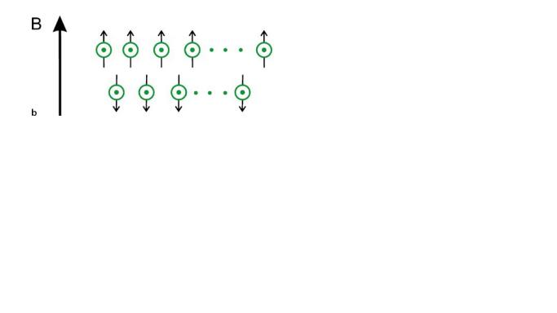
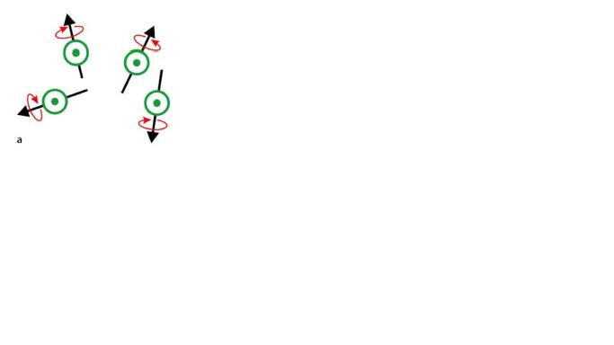
Figure 2. Spins orientation in: a) natural state, randomly distributed spins; b) following the application of a strong magnetic field B₀ the spins achieve one of two possible energy levels. (Adapted from Chysikopoulos, 2009)

While in the presence of the B₀ equilibrium is established and is called the net magnetization (M₀). If the sample is excited by an additional RF pulse then energy transitions can be induced between the two energy states, hence perturbing the M₀ so that a signal can be detected when the spins are returning to the equilibrium state. To the interaction between the spins and the RF pulse is called resonance (Chysikopoulos, 2009).
The direction of the magnetic field B₀ is defined as the z direction in a Cartesian coordinate system, and the motion of each proton can be described by a unique set of coordinates perpendicular (x and y) and parallel (z) to B₀ (Error: Reference source not found).

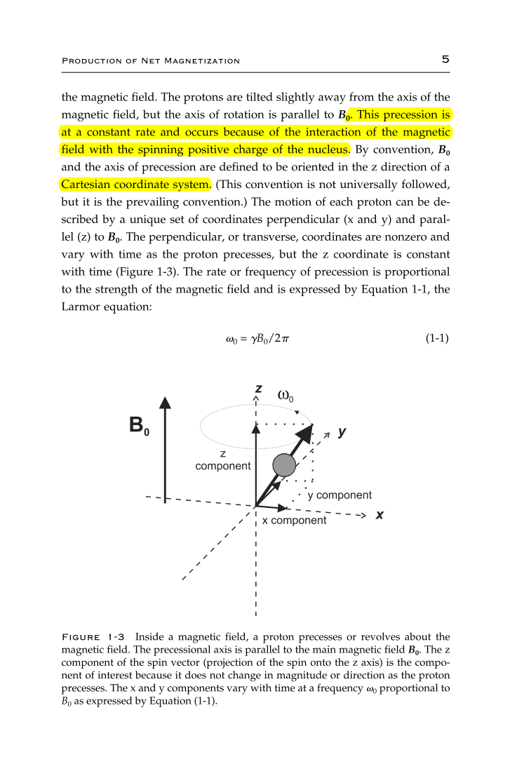
Figure 3. When a RF pulse (B₁) is applied to the constant B₀, a transverse magnetization appears (x,y). The transverse components vary with time as proton precesses. (Adapted from Brown and Semelka, 2003)

After the brief application of the RF pulse the net magnetization returns to the equilibrium state emitting a frequency that is the source of signal for all NMR experiments and is called Free Induction Decay (FID) (Brown and Semelka, 2003). The FID decays with time as more protons loose the absorbed energy from the RF pulse in a process called relaxation.
Relaxation combines two main different mechanisms:
- Longitudinal relaxation time that corresponds to longitudinal magnetization recovery (T1) in the Z axis.
- Transverse relaxation time that corresponds to the transverse magnetization decay (T2) and is related to the loss of coherence between the spins. Due to B₀ inhomogeneities another type of relaxation can be defined, the T2* relaxation. This type of relaxation is more relevant for functional MRI signal, thus, is out of the scope of this text (for more information see Jezzard et al, 2001)
These two types of relaxation provide the primary mechanism for data acquisition with neuroimaging techniques. The FID is detected by a coil surrounding the sample and is then processed to originate the specific type of information desired (images or spectra), depending on the technique which is being used.

Magnetic Resonance Imaging – T1-weighted images
Magnetic resonance imaging (MRI) takes advantage of the high concentration of water in brain tissues (as well as tissues all over the body) and of the measurable magnetic properties of the hydrogen atoms. Using proton density (related to number of hydrogen atoms in the tissue) and the two relaxation times T1 and T2 it is possible to obtain different types of contrasts allowing us to see the boundaries between tissues.
All MRI images are produced using a pulse sequence protocol. The sequence contains radiofrequency pulses and gradient pulses which have controlled duration and timings. The gradient pulses have repetition time (TR) and echo time (TE) which can be modified to achieve the type of tissue contrast desired. TR is the interval between successive excitation pulses that disrupt the net magnetization. TE is the time at which the signal is recorded.
The allowed movement of water and its amount in each type of tissue in the brain (cerebrospinal fluid, gray matter and white matter) gives rise to different T1 relaxation times that will be translated in different brightness values for each tissue type. In cerebrospinal fluid (CSF), where water content is very high and water molecules move freely there is a long T1 relaxation. In gray matter (GM) the water movements are constrained by the cellular wall of the neurons. Also, less water is present then in the CSF thus, GM has lower T1 than CSF. In white matter (WM) the water is even more constrained due to its interaction with myelin, which also leaves less space for the presence of water molecules than in unmyelined neurons (GM), making this tissue the one with the shorter T1 relaxation of the three main brain tissues.
In T1-weighted images short TR and short TE are used to enhance tissue T1 differences and optimize the contrast between WM and GM, making the CSF to have a dark appearance in the image. The shorter the T1 of the tissue the brighter that tissue will appear in the image. Because of the differences in the relaxation curves, WM has a very bright signal and GM has a less bright signal (Error: Reference source not found).
This type of data allows the in vivo study of brain morphometry in a non-invasive way.

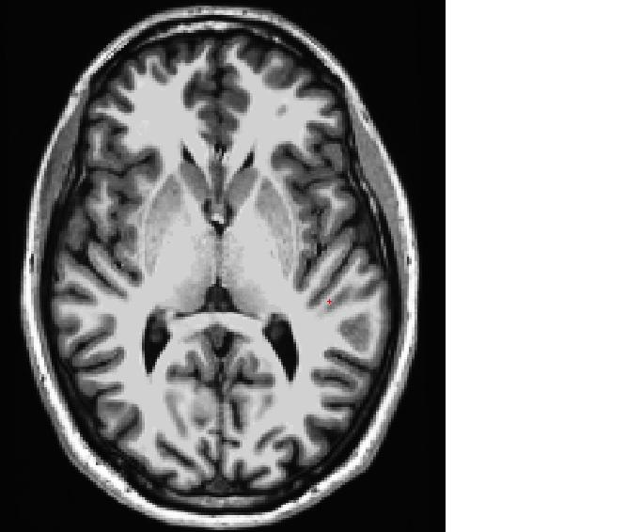
Figure 4. T1-weighted image of the brain (axial view). White matter (WM) is the brightest signal; gray matter (GM) has a gray color; cerebrospinal fluid (CSF) in the ventricles is dark. This type of image provides very good contrast between white matter and gray matter allowing morphometric analysis of these tissues.

Proton Magnetic Resonance Spectroscopy
Another non-invasive neuroimaging technique is the proton magnetic resonance spectroscopy (¹H-MRS). ¹H-MRS provides in vivo chemical information on the relative concentrations and distribution of brain metabolites using the resonance properties of the hydrogen atoms present in molecules. Since almost all metabolites contain protons, ¹H-MRS is an excellent technique to observe and quantify a large number of biologically relevant compounds (de Graaf, 2007). This technique is very useful for studying the normal and pathological brain development. Because it uses the same hardware as MRI it is widely available in clinical and research scanners.
When using ¹H-MRS, rather than anatomical images, data are usually line spectra with the area under the peak representing the relative concentration of the nuclei for a given chemical molecule.
The chemical environment (i.e. the surrounding bounds) in which the hydrogen protons are placed is what allows the same type of nucleus to give information about different metabolites. This is possible because the hydrogen atoms in molecules resonate at slightly different frequencies depending on the surrounding chemical environment. Electrons shield nuclei from the magnetic field B₀ and this shielding depends on the electronegativity of the chemical bounds in which they take part. The less shielding experienced, the higher the chemical shift of the proton nuclei, and vice-versa. This shift is what allows the differentiation of the different metabolites in a spectrum. The resulting frequency shift is reported in a parts per million scale (ppm) which is independent from the external magnetic field applied (McLean and Cross, 2009), making it possible to compare results obtained at different magnetic fields. The resultant spectrum is displayed on x and y axes, where the horizontal x axis plots the frequency chemical shift (ppm) and the vertical y axis plots the relative signal amplitude or proton concentrations of the metabolites (Error: Reference source not found) (Soares and Law, 2009).
¹H-MRS works under the principles above described of NMR, thus depending on the acquisition protocol and echo time (TE), a number of brain metabolites may be assessed in the brain, thus allowing the characterization of different aspects of the tissue. Because the signal starts to decay immediately after the exciting pulse, shorter TE (<40ms) allow the detection of more metabolites than long TE (144-288ms) (Rudkin and Arnold., 1999). Thus, using short TE it is possible to obtain spectra from NAA, Cho, Ins and Cre. At magnetic fields below 4T and TE> 20msec the quantification of glutamate (Glu) and its precursor glutamine (Gln) is difficult, thus the sum of both (Glx) is usually reported (Govindaraju et al., 2000).

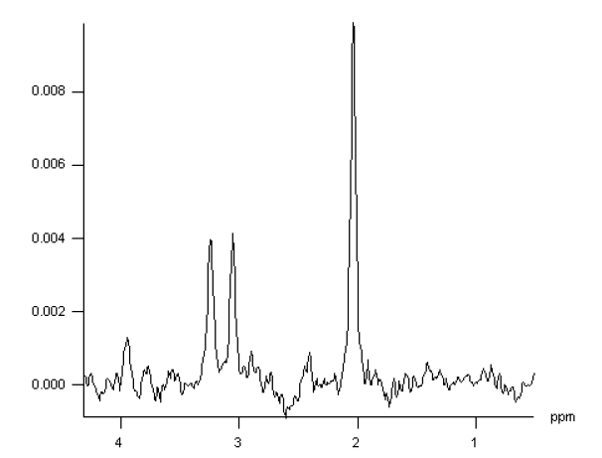
Figure 5. Typical 1H spectrum from normal brain. (Adapted Brown and Semelka, 2003).

Motivation
Widespread brain alterations have been identified in ASD but a consistent neuropathological characterization is still missing. Available studies have shown many inconsistencies, with methodological and technical issues accounting to some extent for the incongruent results. Nevertheless, the great phenotypic and genetic variability present in this spectrum of clinical manifestations also points towards the existence of disease-related clusters that warrant careful investigation.
An effort must be made to avoid possible confounding factors, such has known genetic alterations or intellectual disability, in the study groups. Here we aimed to perform a Neuroimaging study in a homogeneous Portuguese cohort of people diagnosed with ASD. We focused on Magnetic Resonance Imaging (MRI) and Proton Magnetic Resonance Spectroscopy (¹H-MRS).
In sum, we investigated the brain anatomy and neurochemistry in a Portuguese sample of adolescents and adults diagnosed with ASD. Using magnetic resonance imaging (MRI) information of the brain anatomy was obtained, and in a more directed approach we used magnetic resonance spectroscopy (MRS) to get information on the biochemical tissue profile composing the anterior cingulate cortex in same sample where the anatomical data was acquired.
With this protocol we intended to identify anatomical differences that could distinguish between the ASD and the control group.

Methods

Participants
Nineteen individuals participated in this study to date: 12 male adolescents and adults diagnosed with ASD and 7 control male adolescents and adults. Due to exclusion criteria and chosen group-matching concerns (see below), 7 participants from the ASD group were not included in the current analysis. Thus, 5 adolescents and adults with ASD and 7 controls were included in the current analysis.
Adolescents with ASD were recruited from Unidade de Neurodesenvolvimento e Autismo from Centro Desenvolvimento Luis Borges from the Pediatric Hospital of Coimbra where they were evaluated by a pediatrician and psychologists with extensive experience in ASD assessment and diagnosis. Adults with ASD were recruited from two autism associations – Associação Portuguesa para as Perturbações do Desenvolvimento e Autismo (APPDA) of Coimbra and Viseu. These were expressly assessed and evaluated by a psychologist from the Unidade de Neurodesenvolvimento e Autismo from Centro Desenvolvimento Luis Borges for inclusion in this study.
Subjects included in the ASD group (17-33 years of age; mean±SD = 21.8 ± 6.9 years) were diagnosed on the basis of parental interview (Autism Diagnostic Interview– Revised, ADI-R [Lord et al., 1994]), proband assessment (Autism Diagnostic Observation Schedule, ADOS [Lord et al., 1989,1999]), and clinical examination based on the diagnostic criteria for autistic disorder from Diagnostic and Statistical Manual of Mental Disorders IV, DSM-IV (American Psychiatric Association, 1994). All ASD patients had positive results in the ADI-R and/or ADOS for autism or ASD, and met the criteria for autistic disorder from the DSM-IV.
Neuropsychological evaluation was performed using the Portuguese adapted version of the Wechsler Intelligence Scale for children (WISC-III) (Wechsler 2003) and for adults (WAIS-III) (Wechsler, 2008).
Inclusion criterion was full-scale IQ (FSIQ) score above 70, as measured by the Wechsler Intelligence Scales, to exclude subjects with intellectual disability using the World Health Organization International Disease Classification-10 criteria (WHO, 2004). Exclusion criteria were brain morphological abnormalities detected on MRI exam (n=1 ASD), epilepsy or known cytogenetic or genetic syndromes (n=2 ASD). Also, because until date it was not possible to acquire data from control participants younger than 18 years-old using the current protocol (see section 4.2), ASD participants younger than 17 years-old were not included in the current analysis (n=4) so not to bias the age distribution, avoiding developmental differences that could not be taken in account for the control group.
One participant from the ASD group was taking medication at the time of the MRI exam (Risperidone and Tercian). Risperidone is an atypical antipsychotic drug, which blocks dopamine, serotonin and α-adrenergic receptors. It has been used in ASD to reduce aggression and self-injurious behavior (McCracken et al., 2002; Shea et al., 2004). Tercian (cyamemazine) is also a dopamine, serotonine, α-adrenergic and mAch antagonist. This participant was not excluded in the study because none of the medications had an interaction with Glutamate, which was the brain metabolite to be analyzed in this study.
Another participant who is usually medicated (Risperidone) was not taking the medication for at least two weeks before the day of the MRI exam, thus was also included in the study.
Subjects included in the control group were recruited from local population (18-32 years of age; mean ± SD = 24.4 ± 4.4) and were assessed with Social Communication Questionnaire (SCQ) (Rutter et al., 2003) to exclude ASD, and with Wechsler Intelligence Scale to ensure FSIQ above 70. Control participants were healthy, with no previous history of psychiatric or neurologic syndromes.
Informed consent was obtained from parents of participants or, when appropriate, the participants themselves. The study was approved by our local ethics committee (Faculdade de Medicina da Univesidade de Coimbra) and was conducted in accordance with the declaration of Helsinki.

Acquisition protocol
MRI and MRS data were acquired in a 3T Siemens TimTrio scanner at the Portuguese Brain Imaging Network, using a 12-channel birdcage head coil.
Sensomotoric Instruments (SMI) eyetracker was used monitor subjects’ position during the session (Error: Reference source not found). Because movement causes artifacts in the MRI image, and because we had a voxel with a specific spatial localization in the MRS acquisition; the eye tracker device was used to confirm if the subject was staying still during the exams.
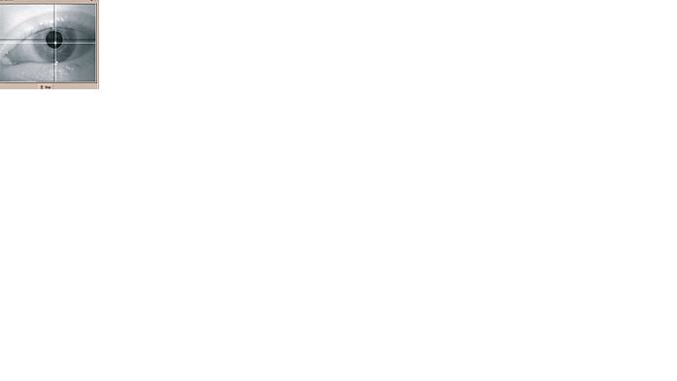
Figure 6. An SMI Eyetracker device was used monitor the subjects during the exam.

MRI acquisition
For each participant two T1-weighted Magnetization Prepared Rapid Acquisition Gradient- Echo (MPRAGE) sequences were acquired with 1x1x1 mm³ voxel size, repetition time (TR)=2.3 s, echo time (TE) = 2.98 ms, flip angle (FA)=9º, field of view (FOV)=256x256, 160 slices, were acquired. This sequence gives rise to high-definition 3-D images with a very good contrast between brain tissues which is suitable for morphometric analysis.
For lesion screening and clinical report a T2-weighted Fluid Attenuated Inversion Recovery (FLAIR) sequence, 1x1x1 mm³ voxel size, TR=5 s, TE=2.98 ms, Inversion Time (TI)=1.8 s, FOV=250x250, 160 slices; and a turbo spin-echo Proton Density and T2-weighted sequence (PD T2), slice Thickness of 3mm, TR= 2970.0 ms, TE=28ms (PD) and 94ms (T2), matrix=320x307 and FOV=23.5mm x 23.5 mm were acquired in the ASD group subjects. Neuroradiological assessment of these sequences was made by an experienced neuroradiologist and a standard clinical report was created.

MRS acquisition
A single-voxel Point-REsolved Spectroscopy (PRESS) sequence was used to obtain spectra from the main brain metabolites. Sequence parameters were TR=2s, TE=30ms, number of averages 128 and 3x3x3 cm³ voxel size. The voxel was located at the anterior cingulate cortex (Error: Reference source not found).
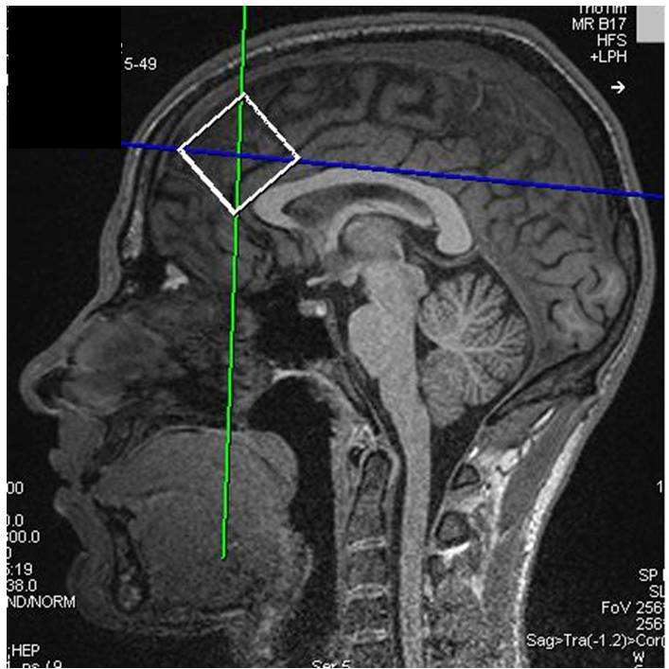
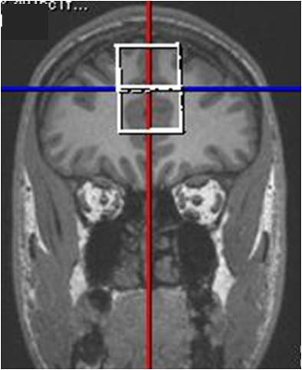
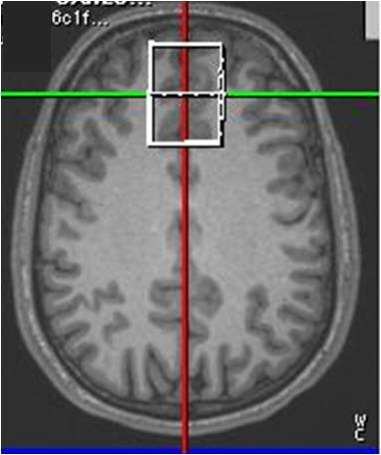
a)9
b)
c)
Figure 7. Localization of the MRS voxel in the anterior cingulate cortex (ACC) in a T1-weighted image. a) sagittal view; b) coronal view and c) axial view.

Immediately after this acquisition another short PRESS acquisition was run with same parameters except for the number of averages which were 4 and with unsupression of the water signal. This short acquisition was necessary for estimation of concentration of metabolites with LCModel software because an unsuppressed spectrum was necessary to obtain absolute metabolites concentration using water as an internal reference (see section 4.3.2).

Data processing

Cortical thickness measurement and subcortical structures segmentation
Cortical reconstruction and volumetric segmentation was performed with the Freesurfer image analysis suite (Dale et al., 1999; Fischl et al., 1999), which is documented and freely available for download online (http://surfer.nmr.mgh.harvard.edu/). Procedures for the measurement of cortical thickness have been validated against histological analysis (Rosas, Liu et al. 2002) and manual measurements (Kuperberg et al., 2003; Salat et al., 2004.
Two anatomical high-resolution T1-weighted images were averaged into one dataset. This procedure yields a better definition than one single anatomical dataset because it increases the signal-to-noise ratio of the resulting averaged image and improves image segmentation (Error: Reference source not found).
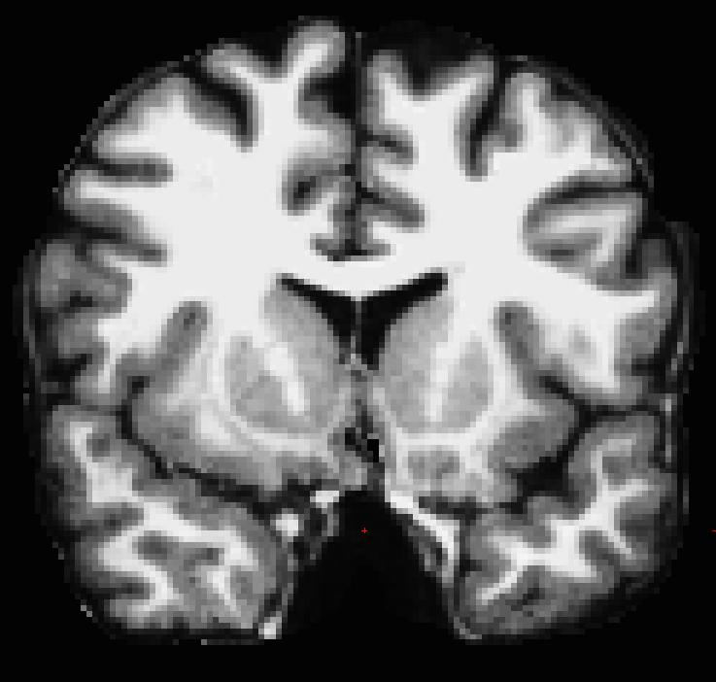
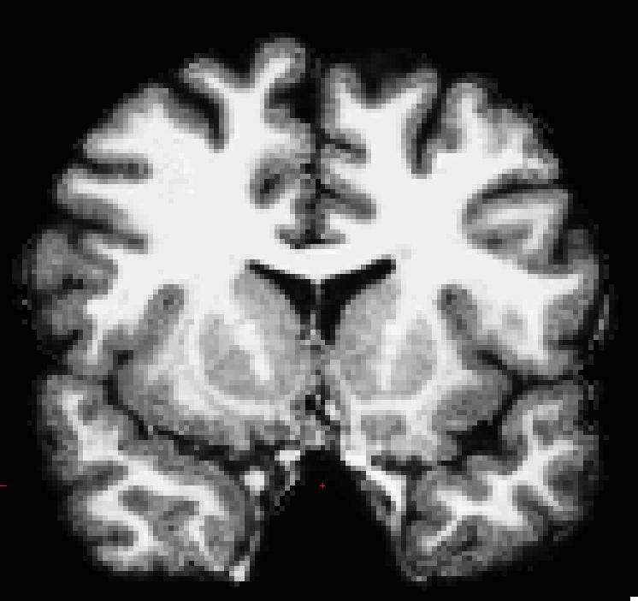
a)
b)
Figure 8. The average of two anatomical acquisitions improves the signal-to-noise ratio (SNR), resulting in a better quality image, appropriate for subsequent segmentation. a) one single anatomical acquisition; b) average of two anatomical acquisitions with improved SNR.

Prior to surface-based morphometry, the high-resolution T1-weighted volume from each participant was bias corrected, skull stripped, transformed to Talairach space and segmented into white matter, gray matter, and cerebrospinal ﬂuid. By this step of processing, subcortical structures (hippocampus, amygdala and basal ganglia) have already been segmented for further analysis (Figure 1). The subcortical segmentation is fully automated and shows high accuracy and agreement with manual labeling (Fischl et al., 2004, Han et al. 2006a; Khan et al., 2009).
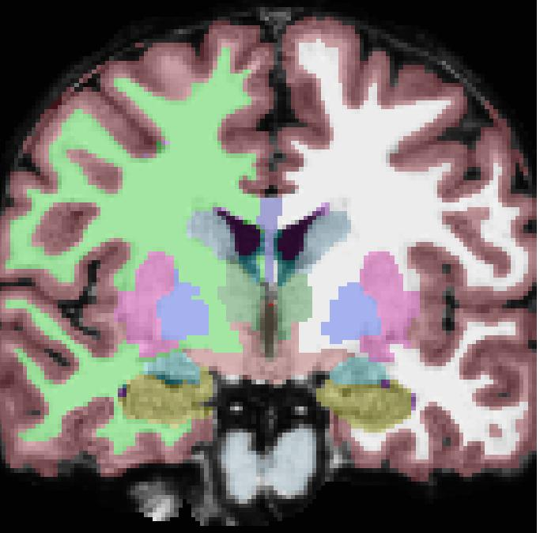
1
2
3
4
5
6

Figure 1. Subcortical segmentation. 1) Putamen; 2) Pallidum; 3) Amygdala; 4) Hippocampus; 5) Caudate; 6) Thalamus. The Accumbens is not visible in this slice.

To reconstruct the white matter (WM)/gray matter (GM) boundary, Freesurfer uses a triangular tessellation process and performs automated topology correction. The WM/GM surface is then expanded to reconstruct the pial surface (GM external limit)(Error: Reference source not found) (Dale et al., 1999; Fischl and Dale, 2000). Since the outer cortical surface is generated by expanding the inner WM/GM surface, there is a one-to-one correspondence between vertices. The cortical thickness is then calculated by finding the closest distance between the two surfaces (red and yellow lines in Error: Reference source not found) (Fischl and Dale, 2000).

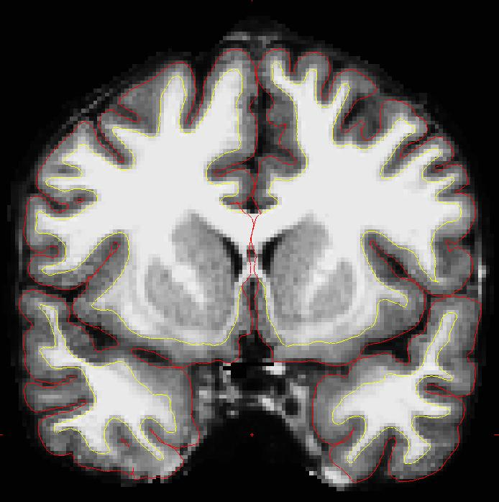
Figure 10. Pial (red) and white matter (yellow) surfaces.

Once the cortical models are complete, deformable procedures are performed for further data processing and analysis including surface inflation (Fischl et al., 1999), registration to a spherical atlas which utilized individual cortical folding patterns to match cortical geometry across subjects. This cortex-based alignment has been demonstrated to improve the spatial correspondences between subject’s brains (Fischl, Sereno et al. 1999). The cortex was parcellated into 34 units per hemisphere based on gyral and sulcal structure (Error: Reference source not found)(Fischl, van der Kouwe et al., 2004; Desikan, Segonne et al., 2006).

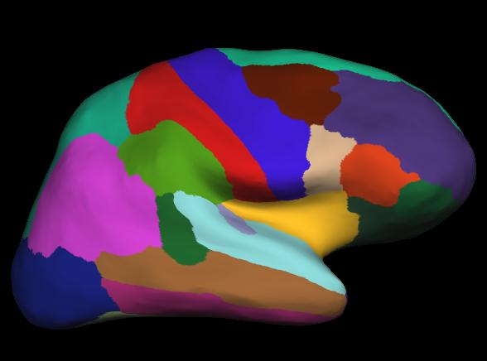
Figure 11. Desikan-Kiliany atlas projected in the inflated surface of a right hemisphere (lateral view).

This is fully automated workflow with little or no manual intervention needed.
However, at some points visual inspection is recommended to check the results and if justified manual correction is performed. Therefore, the above described process of transformation to Talairach space was visually inspected and was corrected when necessary. The surfaces resulting from the cortical segmentation were also visually inspected and if inaccuracies were detected manual correction was made. After manual corrections the software was ran again and the improvements checked in order to continue the processing of the data.
Freesurfer creates table data files with the cortical thickness and volumetric data, these were exported to Excel spreadsheets and then to the statistical analysis software Freesurfer creates data files with the cortical thickness and volumetric data, these were exported to Excel spreadsheets and then to the statistical analysis software.

MRS (LCModel)
LCModel (Linear Combination of Model) software (version 6.2-2) was used to perform quantification of the ¹H-MRS data.
The LCModel analyses in vivo spectra as a Linear Combination of Model of in vitro spectra (basis set) from individual metabolites solution in an automated way, with no user input required (Error: Reference source not found).
Since the in vivo data and the basis set are generally not acquired under identical conditions (scanner, coil loading, etc.), their scaling is different, and the concentrations will all be off (e.g. from mM) by an unknown scale factor. Therefore, for meaningful absolute concentrations, the in vivo data must be first scaled by this factor, so that they are consistent with the basis set. There are two ways to do this with LCModel, either using calibration phantoms or using water-scaling in which the resonance area of the unsuppressed reference water signal is used. Water-scaling was the chosen approach for the present study. Thus, an unsuppressed water acquisition right after the complete sequence acquisition was used to perform this correction. Concentrations are in “institutional” arbitrary units. Only metabolites with a standard deviation less than 20% standard deviation were included for analysis (Provencher, 2011).
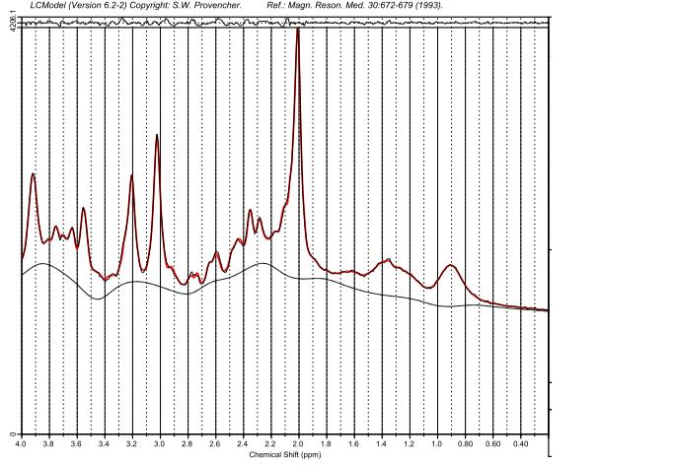
Figure 12. LCModel fitting (red line) of a spectrum obtained from one PRESS acquisition NAA, N-acetylaspartate; Glx, glutamate + glutamine; Cr, creatine + phosphocreatine; Cho, choline-containing compounds; Ins, inositol-containg compounds.

NAA
Cho
Cr
Ins
Glx

Statistical Analysis
SPSS software package (version 19) was used for the statistical analyses of the metabolites concentration obtained with LCModel, as well as for analyzing the Freesurfer imported data of cortical thickness of the 35 regions of interest (ROI) for each hemisphere of the Desikan-Kiliany atlas and volume data of the subcortical structures from each hemisphere.
Normality of data was verified using Shapiro-Wilk test. For the datasets having a normal distribution, an independent samples t Test was used since, and if data did not show equality of variance the corrected p values from the t Test table was used. When the data distribution was not normal, non parametric Mann-Whitney test was used instead. The level of significance for all tests was p≤0.05.
Parametric Pearsons’ correlation analyses was performed when data were normal and presented equality of variance (Leven’s test). When one of the parametric assumptions was not achieved, Spearman non-parametric correlation was used. Again, the level of significance was p≤0.05.

Results

No differences were found between the groups in age (p=0.435) or in intracranial volume (p=0.167), thus no corrections were needed for these two variables that could explain group differences in the subsequent analysis.

Brain morphometry
All 33 regions from each hemisphere were used for group comparisons in order to examine whole brain morphology. For the subcortical segmentation the hippocampus, amygdala, thalamus, caudate, putamen, pallidum and accumbens volumes were analyzed. There were no statistical differences found in the right hemisphere between ASD and the control group either. Nevertheless, a tendency for higher cortical thickness in the right rostral anterior cingulate cortex in the ASD group appeared (p=0.081).
In the left hemisphere statistical differences were found in two frontal regions, the frontal pole (p=0.029) and the medial orbitofrontal cortex (p=0.012), with the ASD group showing increased cortical thickness of these regions (See appendix 1, Table 1.). Also in the left hemisphere, pars triangularis (a part of Broca’s area of language) and paracentral regions had marginally statistically significant differences (p=0.062 and p=0.061, respectively). Again, the ASD group showed higher values for cortical thickness (Figure 14)
Figure 2. a) Medial surface; b) Lateral surface (http://web.mit.edu/mwaskom/pyroi/freesurfer_ref.html#destrieux-atlas-2009).

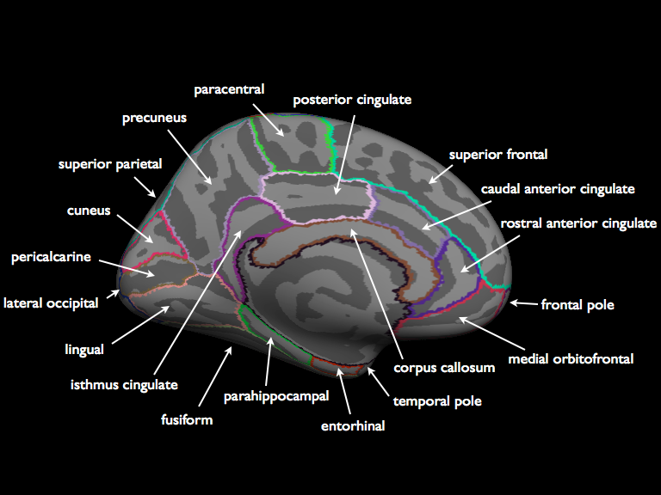
a)

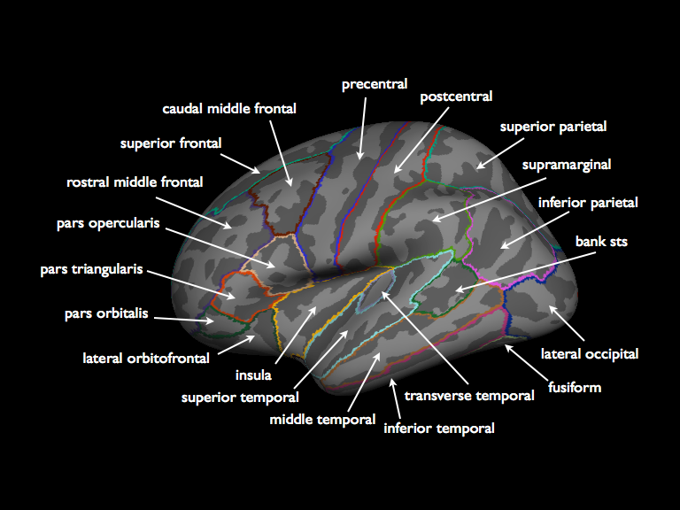
b)

Figure 3. Desikan-Kiliany atlas of the 34 cortical regions analyzed, with the left frontal pole and left orbitofrontal cortex showing increased thickness in the ASD group. a) Lateral surface; B) Medial surface

No statistically significant differences were found between the groups in the volumes of the subcortical structures analyzed (hippocampus, amygdala, caudate nucleus, putamen, pallidum and accumbens). However, for some structures belonging to the basal ganglia the statistical test was near significance, namely the right and left Putamen (p=0.074 and p=0.061, respectively). Also, the left pallidum showed a similar result (p=0.062). All these striatal structures had a tendency for having greater volume in the ASD group.
Table 1. Volumes of the left subcortical structures (mm³)
 | ASD (n=5) | CTRL (n=7) | Test statistics | df | p
R_Thalamus | 7610.80 (504.92) | 7526.86 (702.52) | t=0.227 | 10 | 0.825
R_Caudate | 4246.60 (418.72) | 3885.57 (346.18) | t=1.636 | 10 | 0.133
R_Putamen | 6620.40 (479.35) | 6076.57 (454.67) | t=1.999 | 10 | 0.074
R_Pallidum | 1812.00 (236.47) | 1586.00 (106.62) | t=1.997 | 5.173 | 0.100
R_Hippocampus | 4588.20 (430.99) | 4536.43 (415.71) | t=0.210 | 10 | 0.838
R_Amygdala | 1943.20 (140.47) | 1960.71 (213.93) | t=-0.159 | 10 | 0.877
R_Accumbens | 809.40 (94.65) | 804.71 (110.55) | t=0.077 | 10 | 0.940
Values are mean (SD)
Tabela 2. Volumes of the right subcortical structures (mm³)
 | ASD (n=5) | CTRL (n=7) | Test statistics | df | p
L_Thalamus | 7368.00 (682.63) | 7159.71 (623.85) | t=0.549 | 10 | 0.595
L_Caudate | 4161.00 (489.76) | 3823.71 (307.13) | t=1.475 | 10 | 0.171
L_Putamen | 6908.00 (623.39) | 6253.28 (458.53) | t=2.107 | 10 | 0.061
L_Pallidum | 2150.80 (237.82) | 1900.29 (95.87) | t=2.23 | 4.938 | 0.077
L_Hippocampus | 4393.80 (464.57) | 4468.71 (477.27) | t=-0,271 | 10 | 0.792
L_Amygdala | 1832.40 (106.34) | 1893.71(144.90) | t=-0.800 | 10 | 0.442
L_Accumbens | 773,40 (78.57 | 757.57 (91.08) | t=0.313 | 10 | 0.761
Values are mean (SD)

Figure 4. The graphic shows the volumes (mm³) of the subcortical structures analyzed.

Correlations between cortical thickness and volume of subcortical structures

Correlation analyses were then investigated between the cortical thickness and subcortical regions volume.
Significant correlations were only detected in the left hemisphere, mainly in the ASD group. For the control group only one significant correlation appeared between the putamen and parstriagularis (p=0.024; Pearson=0.821), which was not present in the ASD group. In the ASD group the following significant correlations were detected: the volume of putamen was positively correlated with medial orbitofrontal cortex (p=0.008, Pearson=0.964) and with the rostralanteriorcingulate (p=0.022, Pearson=0.931). The volume of the pallidum was correlated with the thickness of medial orbitofrontal cortex, rostral anterior cingulated cortex and with paracentral region (p<0.001, Spearman’s rho>0.95).

Magnetic resonance spectroscopy
No differences were detected in the concentration of the studied metabolites between the ASD group and the control group in the anterior cingulated cortex (Table 2 and Error: Reference source not found).

Table 2. Brain metabolites concentration comparisons between the two groups.
 | ASD (n=5) | CTRL (n=7) | Test statistics | df | p
NAA | 5.43(0.94) | 5.90(1.16) | U=12.00 | -- | 0.372
Glx | 6.40(2.22) | 5.96(1.28) | t=0.434 | 10 | 0.673
Cr | 4.56(0.80) | 4.45(0.53) | t=0.291 | 10 | 0.777
Cho | 0.99(0.22) | 1.03(0.22) | t=-0.284 | 10 | 0.782
Ins | 4.46(0.42) | 4.10(0.73) | t=0.988 | 10 | 0.347
Metabolites concentration expressed in institutional units; values are mean (SD). U refers to Mann-Whitney test, and t to the parametric t test.
NAA, N-acetylaspartate + N-acetylaspartateglutamic acid; Glx, glutamate + glutamine; Cr, creatine + phosphocreatine; Cho, choline-containing compounds; Ins, inositol-containg compounds.

Figure 16. Bars represent mean(SE) for the Glu, Ins, GPC+PCh. NAA+NAAG and Cr+PCr. No statistical differences were detected between groups.

Discussion

Spectroscopy of the anterior cingulate cortex
Proton MRS provides information which is complementary to the anatomic information available with MRI. In this study we directed our analysis to the anterior cingulate cortex (ACC) for several reasons: because of its structural and functional connectivity with frontrostriatal structures involved in executive function and in the control of the behavior; increased activation in the ACC that was related to higher ratings of repetitive behaviors was reported (Thakkar et al., 2008); and increased ratio of excitation/inhibition in social and emotional systems has also been hypothesized be an underlying neurological mechanism in ASD (Rubenstsein and Merzenich, 2003).
It is important to mention that caution must be taken when trying to reach to conclusions based in crossectional studies about the metabolism since this is a dynamic process. Nevertheless, several studies have been able to report widespread and variable alterations in the main brain metabolites detectable by ¹H-MRS.
In this study no differences were detected in the concentration of the main brain metabolites studied (NAA, Glx, Cr, Cho and Ins) in the anterior cingulate cortex (ACC).
Regarding this region, one study reported decreased levels of Glx in the right ACC of adults with ASD (Bernardi et al, 2011), and studies have reported decreased glucose metabolism and reduced volume also of the right ACC (Haznedar et al., 1997; Haznedar et al., 2011). Possibly, this region shows unilateral changes which we would not capable of detect using one single voxel comprising the ACC bilaterally. Also, subtle alterations requiring high statistical power might not be easily identified with this number of subjects in the ASD group (n=5). Nevertheless, another study was not able to detect metabolic differences between groups of ASD children and controls in the ACC (Vasconcelos et al., 2008), which is in line with the findings of our study.
It is important to note that the lack of differences in the Glx levels do not go against the reasons that lead us to direct our study to this region. Since it is the balance between the main inhibitory neurotransmitter in the brain, gamma-aminobutyric acid (GABA) and glutamate that regulates the excitation/inhibition levels in the cortex (Rubenstsein and Merzenich, 2003). In this particular study we did not address this issue. However, in the future, using special editing spectroscopy sequences that allow the quantification of GABA we will be able to have more conclusive information regarding this topic.

Morphometry

Cortical thickness
The findings of increased cortical thickness in the left hemisphere medial orbitofrontal cortex and frontal pole show anatomical alterations in regions related to the core symptoms of ASD (Amaral et al., 200). Also, the frontal lobe is one of the regions were a greater brain enlargement in the early childhood has been reported (Courchesne et al., 2007), in a crucial period of synapse formation (Huttenlocher and Dabholkar, 1997). Alterations in this region have been linked to the executive function deficit in ASD (ref), by having a function related to planning capacity, working memory, impulse control, and mental flexibility, as well as for the (Just et al., 2007; Hill, 2004) Additionally, the alterations in the orbitofrontal cortex has been shown to have a role in the social cognition impairment in ASD because of its role in decoding others’ mental states ( Sabbagh, 2004),
The direction of the anatomical findings in these regions is not always the in the same direction. This could be related to different developmental trajectories, which can only be completely addressed by means of longitudinal studies. Noteworthy, in a recent study, CT thinning was reported in the medial orbitofrontal cortex, frontal pole and parstriangularis of the left hemisphere in a group of children and adolescents (age range was 6-15 years old) (Jiao et al., 2010).
In our study thicker cortices were surprisingly found in the medial orbitofrontal cortex and frontal pole, with parstriangularis also showing a tendency for greater thickness. In our sample the age range was 17-33 years old. Our findings are more in line with a in a study with 76 individuals, spanning a wide age range, which found that the CT was negatively correlated with age in controls but not in ASD. Temporal CT was smaller in children than controls, with a reverse pattern by middle age/late adulthood when CT was greater in ASD (Raznahan et al., 2010). It is tempting to say that our work and the one of Jiao and colleagues are in agreement with the alterations in the cortical development in ASD. Future work on developmental trajectories should elucidate these apparent discrepancies.

Subcortical structures
The basal ganglia have been implicated in the ASD pathophysiology (Amaral et al., 2008). The caudate nucleus has been the most implicated structure of the basal ganglia, and correlated with lower and higher order stereotypies (Sears et al., 1999; Hollander et al., 2005; Haznedar et al., 2006). In our data, no statistical significance was reached in any of the basal ganglia structures analyzed. However, the putamen showed bilateral tendency for higher volume, as well as the left pallidum. These structures are part of the frontostriatal connections that have been implicated in ASD due to a role in the inhibitory control of behavior.
Interestingly, the statistically significant correlations were found in the left hemisphere of the ASD group between the volume of putamen and the thickness of two regions of the frontal lobe (medial orbitalfrontal cortex rostral anterior cingulate). This positive correlation between subcortical areas involved in automatic, repetitive behavior a cortical areas involved in cognitive control provides intriguing clues into a putative deficit of the switch between automatic and controlled goal oriented behavior in ASD. Another basal ganglia nucleus showing high positive correlation with the frontal lobe was the left pallidum, which also was highly correlated with a region in the paracentral lobe. This region is also referred to as supplementary motor cortex, thus indicating a relationship between one basal ganglia structure directly correlated with an area involved in movement control. This finding may be of interest in the investigation of the neural correlates of motor clumsiness in ASD. This correlation was not found in the control group, were only a correlation between the left putamen and pars triangularis was detected. The latter is a part of the Broca language area, and these findings do thereby providing another putative link link with another cognitive domain affected in ASD. It is tempting to speculate that language impairments are linked to the repetitive and stereotyped behaviors seen in ASD, through in alterations in circuits such as the putaminal-Broca pathway.

Conclusion
Here we have found evidence for morphometric changes, in ASD, of cortical and subcortical structures that are involved in functions related to the core of ASD deficits: automatic and controlled goal oriented behavior. Affected cortical regions were mainly located in the left hemisphere and are involved in social and emotional cognition, and inhibitory control (orbitofrontal cortex) and cognitive flexibility and executive control (frontal pole, also involved in self generated decisions). Morphometric correlation patterns were also consistent with these results, and highlighted intriguing differences in correlation patterns between striatal structures and language and motor control regions.
Future studies with higher statistical power and similarly homogeneous groups should address the generality of some of the findings reported here. Another promising approach in the will be to study neurochemistry in multiple brain regions using novel methods that allow to separate GABA from Glutamate neurotransmission.

Appendix 1.

Cortical thickness analysis statistics
Table 3. Descriptive statistics and between group analysis for the left hemisphere 34 cortical regions studied. The * indicates p<0.05.
Regions | ASD (n=5) | CTRL (n=7) | Test statistics | df | p
L_bankssts | 2.67 (0.21) | 2.55 (0.13) | t=1.175 | 10 | 0.267
L_caudalanteriorcingulate | 2.66 (0.35) | 2.67 (0.24) | U=14.000 | -- | 0.570
L_caudalmiddlefrontal | 2.70 (0.20) | 2.60 (0.15) | t=0.952 | 10 | 0.364
L_cuneus | 2.03 (0.13) | 2.00 (0.16) | t=0.39 | 10 | 0.705
L_entorhinal | 3.39 (0.19) | 3.63 (0.21) | t=-1.248 | 10 | 0.240
L_fusiform | 2.88 (0.26) | 2.83 (0.11) | t=0.542 | 10 | 0.600
L_inferiorparietal | 2.58 (0.17) | 2.46 (0.78) | t=1.679 | 10 | 0.124
L_inferiortemporal | 2.84 (0.18) | 2.83 (0.12) | t=0.012 | 10 | 0.991
L_isthmuscingulate | 2.68 (0.33) | 2.68 (0.14) | t=-0.005 | 10 | 0.996
l_lateraloccipital | 2.29 (0.20) | 2.25 (0.08) | t=0.522 | 10 | 0.613
L_lateralorbitofrontal | 2.66 (0.15) | 2.61 (0.11) | U=12.000 | -- | 0.372
L_lingual | 2.19 (0.13) | 2.20 (0.13) | t=-0.126 | 10 | 0.902
L_medialorbitofrontal | 2.61 (0.10) | 2.39 (0.14) | t=3.067 | 10 | 0.012*
L_middletemporal | 3.10 (0.24) | 2.99 (0.18) | t=0.959 | 10 | 0.360
L_parahippocampal | 2.90 (0.34) | 2.86 (0.20) | t=0.215 | 10 | 0.834
L_paracentral | 2.57 (0.11) | 2.46 (0.14) | U=6.000 | -- | 0.062
L_parsopercularis | 2.72 (0.17) | 2.65 (0.11) | t=0.809 | 10 | 0.437
L_parsorbitalis | 2.78 (0.33) | 2.78 (0.19) | t=0.019 | 10 | 0.985
L_parstriangularis | 2.61 (0.20) | 2.43 (0.09) | t=2.101 | 10 | 0.062
L_pericalcarine | 1.70 (0.06) | 1.73 (0.14) | t=-0.451 | 10 | 0.661
L_postcentral | 2.18 (0.11) | 2.08 (0.10) | t=1.609 | 10 | 0.139
L_posteriorcingulate | 2.72 (0.16) | 2.66 (0.20) | t=0.544 | 10 | 0.598
L_precentral | 2.72 (0.10) | 2.64 (0.17) | t=1.047 | 10 | 0.320
L_precuneus | 2.49 (0.17) | 2.50 (0.07) | t=-0.075 | 10 | 0.942
L_rostralanteriorcingulate | 2.98 (0.40) | 2.98 (0.18) | t=0.03 | 10 | 0.976
L_rostralmiddlefrontal | 2.36 (0.13) | 2.35 (0.07) | t=0.206 | 10 | 0.841
L_superiorfrontal | 2.85 (0.19) | 2.74 (0.08) | t=1.425 | 10 | 0.184
L_superiorparietal | 2.31 (0.16) | 2.25 (0.08) | t=0.837 | 10 | 0.422
L_superiortemporal | 3.02 (0.13) | 2.93 (0.19) | t=0.973 | 10 | 0.354
L_supramarginal | 2.67 (0.11) | 2.59 (0.13) | t=1.055 | 10 | 0.316
L_frontalpole | 2.89 (0.29) | 2.57 (0.13) | t=2.539 | 10 | 0.029*
L_temporalpole | 3.86 (0.24) | 3.84 (0.27) | t=0.144 | 10 | 0.888
L_transversetemporal | 2.38 (0.21) | 2.53 (0.37) | t=-0.81 | 10 | 0.437
L_insula | 3.20 (0.17) | 3.13 (0.13) | t=0.842 | 10 | 0.419

Table 4 Descriptive statisctics and between group analysis for the right hemisphere 34 cortical regions studied. The * indicates p<0.05.
Regions | ASD (n=5) | CTRL (n=7) | Test statistics | df | p
R_bankssts | 2.87 (0.20) | 2.73 (0.18) | t=1.178 | 10 | 0.266
R_caudalanteriorcingulate | 2.54 (0.19) | 2.56 (0.16) | t=-0.146 | 10 | 0.887
R_caudalmiddlefrontal | 2.63 (0.16) | 2.56 (0.91) | t=1.072 | 10 | 0.309
R_cuneus | 2.02 (0.16) | 2.01 (0.94) | t=0.070 | 10 | 0.945
R_entorhinal | 3.85 (0.58) | 3.73 (0.26) | t=0.510 | 10 | 0.621
R_fusiform | 2.93 (0.27) | 2.91 (0.13) | t=0.185 | 5.220 | 0.860
R_inferiorparietal | 2.72 (0.21) | 2.58 (0.96) | t=1.425 | 5.247 | 0.211
R_inferiortemporal | 3.11 (0.33) | 2.99 (0.16) | t=0.767 | 5.413 | 0.475
R_isthmuscingulate | 2.70 (0.25) | 2.70 (0.18) | t=-0.035 | 10 | 0.973
R_lateraloccipital | 2.39 (0.23) | 2.37 (0.13) | t=0.208 | 10 | 0.840
R_lateralorbitofrontal | 2.55 (0.27) | 2.56 (0.17) | U=16.000 | -- | 0.808
R_lingual | 2.25 (0.15) | 2.23 (0.12) | t=0.233 | 10 | 0.820
R_medialorbitofrontal | 2.36 (0.14) | 2.32 (0.13) | t=0.401 | 10 | 0.697
R_middletemporal | 3.13 (0.20) | 3.02 (0.20) | t=0.956 | 10 | 0.362
R_parahippocampal | 2.90 (0.25) | 2.80 (0.34) | t=0.553 | 10 | 0.593
R_paracentral | 2.51 (0.11) | 2.53 (0.12) | t=-0.33 | 10 | 0.748
R_parsopercularis | 2.70 (0.17) | 2.70 (0.06) | t=0.049 | 4.722 | 0.963
R_parsorbitalis | 2.67(0.21) | 2.71 (0.19) | U=15.000 | -- | 0.684
R_parstriangularis | 2.54 (0.16) | 2.50 (0.12) | t=0.574 | 10 | 0.579
R_pericalcarine | 1.75 (0.09) | 1.79 (0.14) | t=-0.617 | 10 | 0.551
R_postcentral | 2.15 (0.15) | 2.13 (0.09) | t=0.278 | 10 | 0.786
R_posteriorcingulate | 2.65 (0.28) | 2.62 (0.15) | t=0.304 | 10 | 0.767
R_precentral | 2.62 (0.11) | 2.65 (0.09) | t=-0.52 | 10 | 0.614
R_precuneus | 2.52 (0.17) | 2.46 (0.08) | t=0.944 | 10 | 0.367
R_rostralanteriorcingulate | 2.97 (0.27) | 2.74 (0.12) | t=1.942 | 10 | 0.081
R_rostralmiddlefrontal | 2.22 (0.12) | 2.24 (0.08) | t=-0.344 | 10 | 0.738
R_superiorfrontal | 2.71 (0.20) | 2.69 (0.10) | t=0.151 | 5.347 | 0.886
R_superiorparietal | 2.31 (0.15) | 2.26 (0.07) | U=15.000 | -- | 0.685
R_superiortemporal | 2.98 (0.10) | 3.02 (0.14) | t=-0.429 | 10 | 0.677
R_supramarginal | 2.68 (0.17) | 2.68 (0.97) | t=0.007 | 5.887 | 0.995
R_frontalpole | 2.77 (0.30) | 2.73 (0.24) | t=0.243 | 10 | 0.813
R_temporalpole | 4.07 (0.46) | 4.12 (0.22) | t=-0.22 | 10 | 0.834
R_transversetemporal | 2.62 (0.25) | 2.60 (0.29) | t=0.180 | 10 | 0.861
R_insula | 3.28 (0.33) | 3.21 80.09) | t=0.487 | 4.412 | 0.650

Graphics
B.1. Mean values with error bars for cortical thickness values of the left hemisphere. The * indicates p<0.05.

B.2. Mean values with error bars for cortical thickness values of the right hemisphere.

References
Amaral D.G., Schumann, C. M. & Nordahl, C. W. (2008). Neuroanatomy of Autism. Trends in Neurosciences, 31(3): 137-145
American Psychiatric Association (2002). DSM-IV-TR, Manual de Diagnóstico e Estatística das Perturbações Mentais (4ª ed.). (J. N. Almeida, Trad.) Lisboa, Portugal: Cimepsi Editores.
Aylward E. H., Minshew N. J., Goldstein G., Honeycutt N. A., Augustine A. M., Yates K. O., Barta P. E. and Pearlson G. D. (1999). MRI volumes of amygdala and hippocampus in non-mentally retarded autistic adolescents and adults. Neurology. 53(9): 2145-2150
Aylward E.H., Minshew N.J., Field K., Sparks B.F. and Singht N. (2002). Effects of age on brain volume and head circumference in autism. Neurology 59:175-183
Barker P.B. (2001). N-acetyl-aspartate: a neuronal marker?. Annals of Neurology. 49: 423-424
Bauman M. L. and Kemper T. L. (2005). The neurobiology of Autism. (2nd ed.). USA. The Johns Hopkins University Press
Bernardi S., Anagnostou E., Shen J., Kolevzon A., Buxbaum J. D., Hollander E., Hof P. R., Fan J. (2011). In vivo 1 H-magnetic resonance spectroscopy study of the attentional networks in autism. Brain research. 1380:198 – 205.
Bradshaw J. L. and Sheppard D. M. (2000). The neurodevelopmental frontrostriatal disorders: evolutionary adaptativeness and anomalous lateralization. Brain and language. 73: 297-320
Brown M. A. and Semelka R. C. (2003). MRI – Basic principles and applications. 3rd edition. John Wiley&Sons, Inc.
Bush G., Luu P. and Posner M. (2000). Cognitive and emotional influences in anterior cingulate cortex. Trends in Cognitive Sciences. 4(6): 215-222.
Carter C. S., Macdonald A. M., Botvinick M., Ross L. L., Stenger V. A., Noll D., and Cohen J. D. (2000). Parsing executive processes: Strategic vs. evaluative functions of the anterior cingulate cortex. PNAS. 15(4):1944 –1948.
Chung M. K., Robbins S. M., Dalton K. M., Davidson R. J., Alexander A. L. and Evans A. C. (2005). Cortical thickness analysis in autism with heat kernel smoothing. Neuroimage. 25: 1256-1265
Chyrikopoulos H. S. (2009). Clinical MR imaging and physics – A tutorial. Springer-Verlag Berilin Heidelberg.
Courchesne E., Karns C. M., Davis H. R., Ziccardi R., Carper R. A., Tigue Z. D., Chisum H. J., Moses P., Pierce K., Lord C., Lincoln A. J., Pizzo S., Schreibman L., Haas R. H., Akshoomoff N. A. and Courchesne R. Y. (2001). Unusual brain growth patterns in early life in patients with autistic disorder: an MRI study. Neurology. 57(2): 245-254
Courchesne E., Pierce K., Schumann C. M., Redcay E., Buckwalter J. A., Kennedy D. P. and Morgan J. (2007). Mapping early brain development in Autism. Neuron 56:399-413
Dager S. R., Wang L., Friedman S. D., Shaw D. W.,Constantino J. N., Artru A. A., Dawson G. and Csernansky L. G. (2006). Shape and mapping of the hippocampus in youg children with Autism Spectrum Disorder. American Journal of Neuroradiology. 28: 672-677
De Graaf R. A. (2007). In Vivo NMR Spectroscopy: Principles and Techniques. 2nd Edition. John Wiley&Sons Ltd. England
Dale A. M., Fischl B. and Sereno M. (1999). Cortical surface-based analysis- I. Segmenation and surface reconstruction. Neuroimage. 9:179-194
Desikan R. S., Segonne F., et al. (2006). An automated labeling system for subdividing the human cerebral cortex on MRI scans into gyral based regions of interest. Neuroimage. 31(3): 968-980.
DeVito T.J., Drost D.J., Neufeld R.W.J., Rajakumar N., Pavlosky W., Williamson P., Nicolson R. (2007). Evidence for cortical dysfunction in Autism: a proton magnetic resonance spectroscopic imaging study. Biological Psychiatry. 61:465-473
Endo T., Shioiri T., Kitamura H., Kimura T., Endo S., Masuzawa N. and Someya T. (2007). Altered chemical metabolites in the amygdala-hippocampus region contribute to autistic symptoms of Autism Spectrum Disorders. Biological Psychiatry. 62: 1030-1037
Fischl B., Sereno M. I., et al. (1999). Cortical surface-based analysis. II: Inflation, flattening, and a surface-based coordinate system. Neuroimage. 9(2): 195-207.
Fischl B. and Dale A.M. (2000). Measuring the thickness of the human cerebral cortex from magnetic resonance images. PNAS. 97(20): 11050-11055
Fischl B., Salat D.H., van der Kouwe A.J., Makris N., Segonne F., Quinn B.T., Dale A.M., 2004. Sequence-independent segmentation of magnetic resonance images. Neuroimage.
Fischl B., van der Kouwe A., et al. (2004). Automatically parcellating the human cerebral cortex. Cereb Cortex. 14(1): 11-22.

Fombonne E. (2007). Epidemiological surveys of pervasive developmental disorders. In (Fred R. Volkmar, Ed) Autism and Pervasive Developmental Disorders (2nd ed.). New York: Cambridge University Press
Fombonne E. (2003). Epidemiological surveys of Autism and other developmental disorders: an update. Journal of Autism and Developmental Disorders. 33(4): 365-382
Friedman S.D., Shaw D.W., Artru A.A., Dawson G., Petropoulos H. and Dager S.R. (2006). Gray and white matter brain chemistry in young children with Autism. Archives of General Psychiatry 63: 786-794
Fujii E., Mori K., Miyazaki M., Hashimoto T., Harada M. and Kagami S. (2010). Function of the frontal lobe in autistic individuals: a proton magnetic resonance spectroscopy study. The Journal of Medical Investigation. 57:35-44
Gabis L., Huang W., Azizian A., DeVicent C., Tudorica A., Kesner-Baruch Y., Roche P. and Pomeroy J. (2008). ¹H-magnetic resonance spectroscopy markers of cognitive and language ability in clinical subtypes of Autism Spectrum Disorders. Journal of Child Neurology. 23 (7):766-774
Geschwind D. H. (2009). Advances in Autism. Annual Review Of Medicine. 60: 367-380
Govindaraju V., Young K., Maudsley A. A. (2000). Proton chemical shifts and coupling constants for brain metabolites. NMR in Biomedicine. 13:129-153
Hadjikhani N., Joseph R. M., Snyder J. and Tager-Flusberg H. (2006). Anatomical differences in the mirror neuron system and social cognition network in Autism. Cerebral Cortex. 16: 1276-1282
Han X., Jovicich J., Salat D., van der Kouwe A., Quinn B., Czanner S., Busa E., Pacheco J., Albert M., Killiany R., Maguire P., Rosas D., Makris N., Dale A., Dickerson B., Fischl B. (2006). Reliability of MRI-derived measurements of human cerebral cortical thickness: the effects of field strength, scanner upgrade and manufacturer. Neuroimage. 32: 180-194.
Hardan A. Y., Libove R. A., Keshavan M. S., Melhem N. M. and Minshew N. J. (2009). A preliminary magnetic resonance imaging study of brain volume and cortical thickness in Autism. Biological Psychiatry. 66:320-326
Hardan A.Y., Libove R. A., Keshavan M. S., Melhem N. M. and Minshew N. J. (2009). A preliminary study of brain volume and cortical thickness in Autism. Biological Psychiatry. 66: 320-326
Haznedar M. M., Buchsbaum M. S., Hazlett E. A., LiCalzi E. M., Cartwright C. and Hollander E. (2006). Volumetric analysis and three-dimensional glucose metabolic mapping of the striatum and thalamus in patients with autism spectrum disorders. American Journal of Psychiatry. 163: 1252-1263
Haznedar M. M., Buchsbaum M. S., Wei T. hof P. R., Cartwright C., Bienstock C. A. and Hollander E. (2000). Limbic circuitry in patients with autism spectrum disorders studied with positron emission tomography and magnetic resonance imaging. American Journal of Psychiatry. 157:1994-2001
Herbert M. R., Ziegler D. A., Deutsch C. K., O’Brien L. M., Lange N., Bakargjiev A., Hodgson J., Adried K. T., Steele S., Makris N., Kennedy D., Harris G. J. and Caviness Jr. V. S. (2003). Dissociations of cerebral cortex, subcortical and cerebral white matter volumes in autistic boys. Brain. 126:1182-1192
Hollander E., Anagnostou E., Chaplin W., Esposito K., Haznedar M. M., Licalzi E., Wasserman S., Soorya L. and Buchsbaum M. (2005). Biological Psychiatry. 58: 226-232
Huttenlocher P. R. and Dabholkar A. S. (1997). Regional differences in synaptogenesis in human cerebral cortex. The Journal of Comparative Neurology. 387: 167-178
Hyde K. L., Samson F., Evans A. C. and Mottron L. (2010). Neuroanatomical differences in brain areas implicated in perceptual and other core features of Autism reveled by cortical thickness analysis and voxel-based morphometry. Human Brain Mapping. 31:556-566
Jezzard P., Mathews P. M. and Smith S. Functional MRI – an introduction to methods. Oxford University Press.
Jones S.E., Buchbinder B.R. and Aharon I. (2000). Three-dimensional mapping of cortical
Kabani N., Le Goualher G., MacDonald D. and Evans A. C. (2001). Measurement of cortical thickness using an automated 3-d algorithm: A validation study. NeuroImage, 13:375–380
Khan A. R., Wangb L., Bega M. F. (2008). FreeSurfer-Initiated Fully-Automated Subcortical Brain Segmentation in MRI Using Large Deformation Diffeomorphic Metric Mapping. Neuroimage. 41(3): 735–746.
Kleinhans N. M., Schweinsburg B. C., Cohen D. N., Muller R. and Courchesne E. (2007). N-acetyl aspartate in autism spectrum disorders: regional effects and relationship to fMRI activation. Brain Research. 1162: 85-97
Kuperberg G.R., Broome M.R., McGuire P.K., David A.S., Eddy M., Ozawa F., Goff D., West W.C., Williams S.C., van der Kouwe A.J., Salat D.H., Dale A.M., Fischl B. (2003). Regionally localized thinning of the cerebral cortex in schizophrenia. Arch Gen Psychiatry. 60: 878-888.
Langen M., Durston S., Staal W. G., Palmen S. J. M. C. and Engeland H. (2007). Caudate nucleus is enlarged in high-functioning medication-naïve subjects with autism. Biological Psychiatry. 62: 262-266
Leite R. A. A., Otaduy M. C. G., Silva G. E. G., Ferreira M.L.B. and Aragão M.F.V. (2010). Diagnostic methods for extra-temporal neocortical focal epilepsies: Present and future. Arq. Neuropsiquiatria. 68(1) 119-126
Levitt J.G., O´Neill J., Blanton R.E., Smalley S., Fadale D., McCracken J.T., Guthrie D., Toga A.W. and Alger J.R. (2002). Proton magnetic resonance spectroscopy imaging of the brain in childhood autism. Biological Psychiatry. 54: 1355-1366
Lord C, Rutter M, DiLavore P, Risi S. (1999). Autism Diagnostic Observation Schedule (ADOS) Los Angeles, Calif: Western Psychological Services.
Lord C, Rutter M, Le Couteur A. (1994). Autism Diagnostic Interview-Revised: a revised version of a diagnostic interview for caregivers of individuals with possible pervasive developmental disorders. J Autism Dev Disord. 24:659-685.
Lord C, Rutter M, DiLavore P, Heemsbergen J, Jordan H, Mawhood L, et al. (1989). Autism diagnostic observation schedule: a standardized observation of communicative and social behavior. J Autism Dev Disord. 19:185-212..
McAlonan G. M., Daly E., Kumari V., Critchley H. D., Amelsvoort T., Suckling J., Simmons A., Sigmundsson T., Greenwood K., Russel A., Schmitz N., Happe F., Howlin P. and Murphy D. G. M. (2002). Brain anatomy and sensorimotor gating in Asperger’s syndrome. Brain. 127: 1594-1606
Mclean M.A. and Cross J.J. (2009). Magnetic resonance spectroscopy: principles and applications to neurosurgery. British Journal of Neurology. 23(1):5.13.
Mclean M.A., Woermann F.G., Barker G.J., Duncan J.S. (2000). Quantitative analysis of short echo time ¹H-MRSI of cerebral gray and white matter. Magnetic Resonance in Medicine. 44:401–11.
Meshcer M., Merkle H., Kirsch J., Garwood M., and Grueetter R. (1998). Simultaneous in vivo spectral editing and water suppression. NMR in Biomedicine. 11: 266-272
Moreya R. A, Pettya C. M., Xua Y., Hayesa J. P., Wagner II H. R., Lewisa D. V., LaBara K. S., Stynerg M., McCarthya G. (2009 April 15). A comparison of automated segmentation and manual tracing forquantifying hippocampal and amygdala volumes. Neuroimage. 45(3): 855–866. doi:10.1016/j.neuroimage.2008.12.033.
Morgane P. J., Galler J. R. and Mokler D. J. (2005). A review pf systems and networks of the limbic forebrain/limbic midbrain. Progress in Neurobiology. 75: 143-160
Mosconi M. W., Cody-Hazlett H., Poe M. D., Gerig G., Gimpel-SmithR. and Piven J. (2009). Longitudinal study of amygdala volume and joint attention in 2- to 4-year-old children with autism. Archives of General Psychiatry. 88(5): 509-516
Munson J., Dawson G., Abbot R., Faja S., Webb S. J., Friedman S. D., Shaw D., Artru A. and Dager S. R. (2006). Amygdalar volume and behavioral development in autism. Archives of General Psychiatry. 63(6): 686-893
Murphy D. G. M., Crichtley H. D., Schmitz N., McAlonan G., Amelsvoort T., Robertson D., Daly E., Rowe A., Russel A., Simmons A., Murphy K. C. and Howlin P. (2002). Asperger Syndrome: a proton magnetic resonance spectroscopy study of brain. Archives of General Psychiatry. 59: 885-891
Nicolson R., DeVito T. J., Vidal C. N., Sui Y., Hayashi K. M., Drost D. J., Williamson P. C., Rajakumar N., Toga A. W. and Thompson P. M. (2006). Detection and mapping of hippocampal abnormalities in autism. Psychiatric Research: Neuroimaging. 148: 11-21
Oliveira G., Ataíde A., Marques C., Miguel T. S., Coutinho A. M., Mota-Vieira L., Gonçalves E., Lopes N. M., da Mota H. C. and Vicente A. M. (2007). Epidemiology of autismo Spectrum disorder in Portugal: prevalence, clinical characterization, and medical conditions. Developmental Medicine & Child Neurology. 49: 726-733
Page L.A., Daly E., Schmitz N., Simmons A., Toal F., Deeley Q., Ambery F., McAlonan G.M., Murphy K.C. and Murphy D.G.M. (2006). In vivo H-Magnetic Resonance Spectroscopy study of amygdala-hippocampal and parietal regions in Autism. American Journal of Psychiatry. 163: 2189-2192
Piven J., Bailey J., Ranson B. J. and Arndt S. (1998). No differences in hippocampus volume detected on magnetic resonance imaging in autistic individuals. Journal of Autism and Developmental Disorders. 28: 105-110.
Provencher S. W. (2001). Automatic quantitation of localized in vivo 1H spectra with LCModel. NMR Biomed. 14:260–4.
Raznahan A., Toro R., Daly E., Robertson D., Murphy C., Deeley Q., Bolton P.F, Paus T. and Murphy D. G. M. (2010). Cortical anatomy in Autism Spectrum Disorder: an in vivo MRI study on the effect of age. Cerebral Cortex. 20: 1332-1340
Redcay E. and Courchesne E. (2005). When is the brain enlarged in Autism? A meta-analysis of all brain size reports. Biological Psychiatry. 58: 1-9
Rosas H. D., Liu A. K., et al. (2002). Regional and progressive thinning of the cortical ribbon in Huntington's disease. Neurology. 58(5): 695-701.
Rosas H.D., Liu A.K., Hersch S., Glessner M., Ferrante R.J., Salat D.H., van der Kouwe A., Jenkins B.G., Dale A.M., Fischl B., (2002). Regional and progressive thinning of the cortical ribbon in Huntington's disease. Neurology. 58: 695-701.
Ross B. and Bluml S. (2001). Magnetic resonance spectroscopy of the human brain. The Anatomical Record. 265: 54-84.
Rubenstein J. L. R. and Merzenich M. M. (2003). Model of autism: increased ratio of excitation/inhibition in key neuronal system. Genes, Brain and Behavior. 2: 255-267
Rudkin T. M. and Arnold D. L. (1999). Proton magnetic resonance spectroscopy for the diagnosis and management of cerebral disorders. Archives of Neurology. 56:919-926
Rutter M., Bailey A. and Lord C., (2003). Social communication questionnaire: SCQ, Western Psychological Services, Los Angeles, USA
Salat D. H., Buckner R. L., et al. (2004). Thinning of the cerebral cortex in aging. Cereb Cortex. 14(7): 721-730.
Salat D.H., Buckner, R.L. Snyder A.Z., Greve D.N., Desikan R.S., Busa E., Morris J.C., Dale A.M., Fischl B. (2004). Thinning of the cerebral cortex in aging. Cereb Cortex 14: 721-730.
Schaer M. and Eliez S. (2009). Contribution of structural brain imaging to our understanding of the cortical development process. European Psychiatric Review. pp 13-16
Schumann C. M., Barnes C. C., Lord C. and Courchesne E. (2009). Amygdala enlargement in toodlers with autism related to severity of social and communication impairments. Biological Psychiatry. 66(10): 942-949
Schumann C. M., Hamstra J., Goodlin-Jones B. L., Lotspeich L. J., Kwon H., Buonocore M. H., Lammers C. R., Reiss A. L. and Amaral D. G. (2004). The amygdala is enlarged in children but not adolescents with autism; the hippocampus is enlarged at all ages. The Journal of Neuroscience. 24(28): 6392-6401
Sears L. L., Vest C., Mohamed S., Bailey J., Ranson B. and Piven J. (1999). An MRI study of the basal ganglia. Biological Psychiatry. 23: 613-624
Shaw P., Greenstein D., Lerch J., Clasen L., Lenroot R., Gogtay N., Evans A., RapoportJ., and Giedd J., (2006a). Intellectual ability and cortical development in children and adolescents. Nature. 440: 676-679.
Shaw P., Lerch J., Greenstein D., Sharp W., Clasen L., Evans A., Giedd J., Castellanos F. X., Rapoport J. (2006b). Longitudinal Mapping of Cortical Thickness and Clinical Outcome in Children and Adolescents With Attention-Deficit/Hyperactivity Disorder. Arch Gen Psychiatry. 63(5):540-9.
Soko D. K., Dunn D. W., Edwards-Brown M. and Feinberg J. (2002). Hydrogen proton magnetic resonance spectroscopy in autism: preliminary evidence of elevated Choline/Creatine ratio. Journal of Child Neurology. 17: 245-249
Sparks B. F., Friedman S. D., Shaw D. W., Aylward E. H., Echelard D., Atru A. A., Maravilla K. R., Giedd J. N., Munson J., Dawson G. and Dager S. R. (2002). Brain structural abnormalities in young children with autism spectrum disorders. Neurology. 59: 184-192
Stanfield A. C., McIntosh A. M., Spencer M.D., Philip R., Gaur S. and Lawrie M. (2008). Towards a neuroanatomy of autism: a systematic review and meta-analysis of structural magnetic resonance imaging studies. European Psychiatry. 23: 289-299
Soares D.P. and Law M. (2009. Magnetic resonance spectroscopy of the brain: review of metabolites and clinical applications. Clinical Radiology. 64:12-21
Talairach J, Tornoux P. (1988). Co-planar stereotaxic atlas of the human brain: 3-dimensional proportional system: an approach to cerebral imaging. Stuttgart: Georg Thieme
thickness using Laplace’s equation. Human Brain Mapping. 11: 12–32
Urenjak J., Williams S.R., Gadian D.G., Noble M. (1993). Proton nuclear magnetic resonance spectroscopy unambiguously identifies different neural cell types. Journal of Neurosciences. 13: 981-989
Vasconcelos M. M., Brito A.R., Domingues R.C., da Cruz Jr. L.C.H., Gasparetto E.L., Werner J., Gonçalves J. P. S. (2008). Proton magnetic resonance spectroscpy in school-aged autistic children. Journal of Neuroimaging. 18:288-295
Wallace G. L., Danker N., Kenworthy L., Giedd J. N. and Martin, A. (2010). Age-related temporal and parietal cortical thinning in autism spectrum disorders. Brain. 133: 3745-3754
Wechsler D. (2008). Manual for intelligence scale for adults (3rd ed.). Lisbon: Cegoc-Tea
Wechsler D. (2003). Manual for intelligence scale for children (3rd ed.). Lisbon: Cegoc-Tea.
Wechsler, D. (2003). Escala de Inteligência de Wechsler para Crianças – Terceira Edição (WISC-III): Manual. Lisboa, Cegoc-Tea.
World Health Organization - International statistical classification of diseases and related health problems: tenth revision, 2nd Edition 2004 (www.who.int/classificatio

Bias field correction is needed due to scanner magnetic field inhomogeneities. White matter voxels are assigned with a unique intensity value.
Skull stripping is the removal of non-brain tissue.
Talairach transformation is made to have all volumes in a standard space (Talairach and Tournoux, 1988)

